# UNIVERSITY OF ILORIN, ILORIN

# FACULTY OF PHYSICAL SCIENCES, DEPARTMENT OF PHYSICS

**Course Code:** PHY 115

**COURSE TITLE:** Mechanics and Properties of Matter

**Prepared by:** Dr. S.A. Bello, Dr. O.A. Falaiye, Dr. T.O. Lawal, Mr. K.A. Yusuf

**1.0 Introduction**

Mechanics and Properties of Matter is a 2 – credits course that is available to students offering Bachelor of Science (B.Sc.) in Computer Science.

The course provides student with the basic knowledge of understanding the principles and applications of physics of mechanics and properties of matter. It is also to prepare students towards scientific advancement in classical mechanics, fluid dynamics, and works on relativity theory among others.

**2.0 Learning Outcome**

At the end of the course students will be able to:

1. explain the unit and dimension of a physical system
2. describe the position and direction of a particle through the use of vector and scalar quantity.
3. explain the motion of an object without the requisite description of the forces causing the motion
4. applying the three newton’s laws of motion
5. explain the system of particles involving the intermolecular forces, elasticity of a material and motion of vibration in an object.
6. describe the center of mass of an object and calculation of its moment of inertia
7. explain fluid mechanics and related physical concepts such as drag, viscosity, surface tension and buoyancy

**Course Guide**

**Module 1: Dimension Analysis**

Unit 1: Units and Dimension

Unit 2: Vector and Scalar I

Unit 3: Vector and Scalar II

**Module 2** Particle Kinematics in Two Dimensions

Unit 1: One-Dimensional Rectilinear Motion

Unit 2: Projectile

**Module 3: Force and Motion**

Unit 1: Dynamics Newton’s Law of Motion

Unit 2: Friction, Work and Energy

**Module 4:** Oscillation

Unit 1: Intermolecular Force and Elasticity

Unit 2: Simple Harmonic Motion

**Module 5:** System of Particles

Unit 1: Center of mass

Unit 2: Rigid Body Dynamics

**Module 6:** Fluid Mechanics

Unit 1: Pressure in a fluid

Unit 2: Fluids in Motion

Unit 3: Viscosity

Unit 4: Stoke’s Law

Unit 5: Surface Tension

**Module 1: Dimension Analysis**

**Unit 1:** Units and Dimension

1.0 Introduction

2.0 Learning Outcomes

3.0 Main Content

3.1 Standard and Unit

3.2 The International System of Units

3.3 Base vs. Derived Quantities

3.4 Units Conversion

3.5 Table Notes

3.6 Dimension and Dimension Analysis

4.0 Summary

5.0 Self-Assessment

6.0 Tutor Marked Assignment

7.0 References

8.0 Further Reading

**1.0 Introduction**

This unit focuses on the basic requisite language and analytical techniques that are specific to physics. The unit will include the fundamental knowledge of measurement units and scientific notation, standardization of units and unit conversion.

**2.0 Learning Outcomes**

When you have studied this unit, you should be able to:

1. identify the base quantities in the SI system.
2. name the most frequently used prefixes for SI units.
3. perform unit conversion using chain-link method.
4. solve problems with the values of the most common metric prefixes.
5. explain the difference between base and derived unit.
6. be able to apply the method of dimensional analysis to find approximate relationships between the physical quantities that describe a system

**3.0 Main Content**

**3.1 Standard and Unit**

Science and engineering centred on measurements and comparison. Physics is an experimental science. As a consequence, we need rules about how things are measured and compared, and we need experiments to establish the units for those measurements and comparisons. Experiments require measurements, and we generally use numbers to describe the results of measurements. Any number that is used to describe a physical phenomenon quantitatively is called a **physical quantity.**

The **physical quantities** make the foundation of physics upon which the known laws of physics are expressed. Therefore, these quantities are expected to be accurately measured. A physical quantity is defined by a numerical value and a unit. For example, two physical quantities that describe you are your weight and your height. Some physical quantities are so fundamental that we can define them only by describing how to measure them. Such a definition is called an **operational definition.** Two examples are measuring a distance by using a ruler and measuring a time interval by using a stopwatch. In other cases we define a physical quantity by describing how to calculate it from other quantities that we *can* measure. Thus we might define the average speed of a moving object as the distance travelled (measured with a ruler) divided by the time of travel (measured with a stopwatch).

Physical quantities are measure in their **units** and compared with a reference **standard**. The **unit** is a unique name we assign to measures of that quantity—for example, meter (m) for the quantity length. The standard corresponds to exactly 1.0 unit of the quantity. As you will see, the standard for length, which corresponds to exactly 1.0 m, is the distance travelled by light in a vacuum during a certain fraction of a second.

To make accurate, reliable measurements, we need units of measurement that do not change and that can be duplicated by observers in various locations. The system of units used by scientists and engineers around the world is commonly called “the metric system,” but since 1960 it has been known officially as the **International System,** or **SI** (the abbreviation for its French name, *Système* *International*).

**3.2 The International System of Units**

There are so many physical quantities that it is a problem to organize them. Fortunately, they are not all independent; for example, speed is the ratio of a length to a time. Thus, what we do is pick out—by international agreement—a small number of physical quantities, such as length and time, and assign standards to them alone. We then define all other physical quantities in terms of these ***base quantitie*s** and their standards (called ***base standards***). Speed, for example, is defined in terms of the base quantities length and time and their base standards. **Base standards** must be accessible, invariable and readily reproducible so that anyone needing to make a very accurate measurement can refer to the standard in the laboratory and communicate with other people.

In 1971, the 14th General Conference on Weights and Measures picked seven quantities as base quantities, thereby forming the basis of the International System of Units, abbreviated SI from its French name and popularly known as the *metric system*. Table 1-1 shows the units for the three **base quantities**—length, mass, and time—that we use in the early chapters of this book. These units were defined to be on a “human scale.” Many SI *derived units* are defined in terms of these base units. For example, the SI unit for power, called the **watt** (W), is defined in terms of the base units for mass, length, and time.

**3.3 Base vs. Derived Quantities**

Physical quantities can be divided into two categories: *base quantities* and *deri*v*ed quantities*. The corresponding units for these quantities are called *base* *units* and *deri*v*ed units*.

A **base quantity** must be defined in terms of a standard. Scientists, in the interest of simplicity, want the smallest number of base quantities possible consistent with a full description of the physical world.

*A base quantity (or fundamental quantity) is a quantity which cannot be expressed in terms of any other physical quantity. The units in which these quantities are measured are called base units (or fundamental units).*

The base unit number turns out to be seven, and those used in the SI are given in Table 1.

**Table 1:** SI Base Quantities and Units

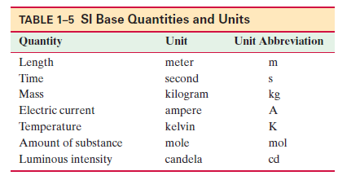

All other quantities can be defined in terms of these seven base quantities, and hence are referred to as **derived quantities**. Table 2 lists many derived quantities and their units in terms of base units.

An example of a derived quantity is speed,

Other examples are

To define any quantity, whether base or derived, we can specify a rule or procedure, and this is called an **operational definition**.

**Table 2:** SI Derived Quantities and Units

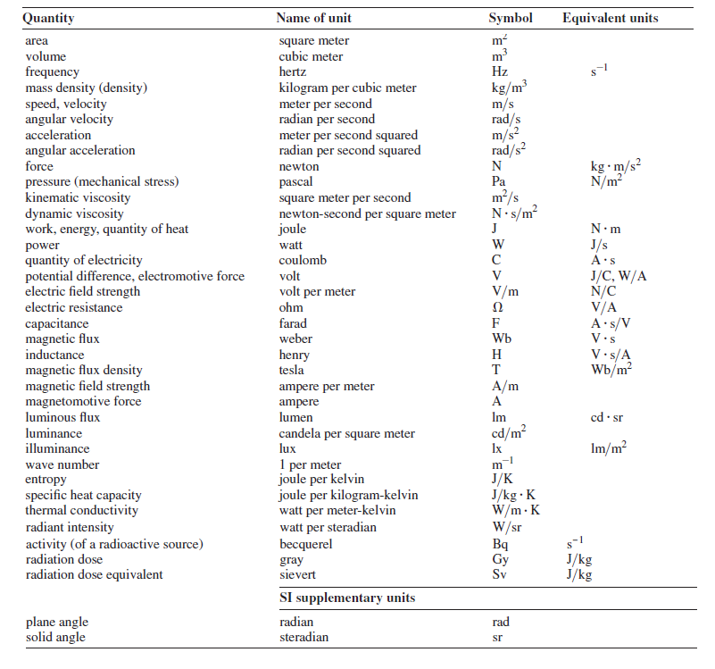

To express the very large and very small quantities we often run into in physics, we use *scientific notation*, which employs powers of 10. In this notation,

and

Scientific notation on computers sometimes takes on an even briefer look, as in 7.56 E9 and 5.46 E–7, where E stands for exponent of ten. It is briefer still on some calculators, where E is replaced with an empty space.

As a further convenience when dealing with very large or very small measurements, we use the prefixes listed in Table 3. As you can see, each prefix represents a certain power of 10, to be used as a multiplication factor. Attaching a prefix to an SI unit has the effect of multiplying by the associated factor. Thus, we can express Nigeria maximum power generated in the early 2018 as

**Table 3: Prefixes for SI Units**

## 

## 3.4 Units Conversion

Sometime there is the need to convert the units in which a physical quantity is expressed. We do so by a method called *chain-link conversion*. In this method, we multiply the original measurement by a **conversion factor** (a ratio of units that is equal to unity). For example, because 1 min and 60 s are identical time intervals, we have

Thus, the ratios (1 min)/(60 s) and (60 s)/(1 min) can be used as conversion factors. This is *not* the same as writing or 60 =1 ; each *number* and its *unit* must be treated together.

Because multiplying any quantity by unity leaves the quantity unchanged, we can introduce conversion factors wherever we find them useful. In chain-link conversion, we use the factors to cancel unwanted units.

**Example 2**

Convert 5 min to seconds.

Alternative method

Let represent the answer with ‘Ans’

**Example 2**

If the weight of your class *representative* is 7000g. Covert this weight from *kg* unit to grams, *g*.

**Solution**

Let represent the answer with ‘Ans’

Divide both side by 1000 g, we have

If you introduce a conversion factor in such a way that unwanted units do *not* cancel, invert the factor and try again. In conversions, the units obey the samealgebraic rules as variables and numbers. The next subsection gives the table note for conversion factors between SI and other systems of units,including non-SI units still used in the United States.

**3.5 Table Notes**

**3.5.1 Conversion Factor**

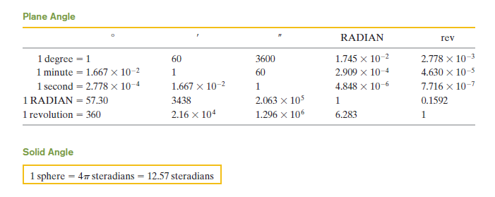

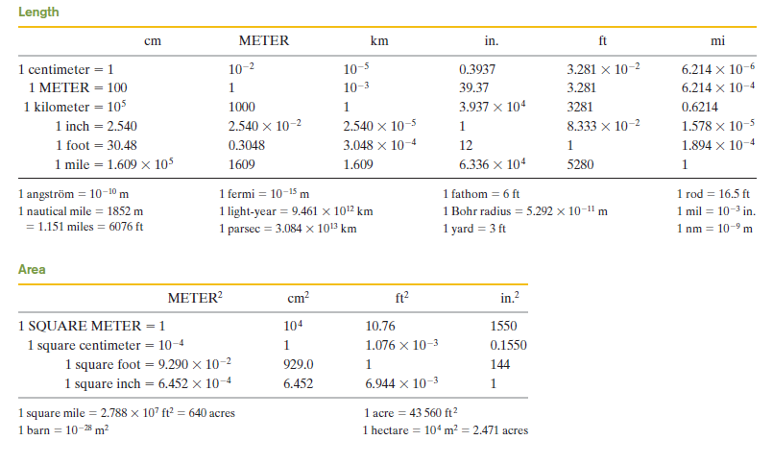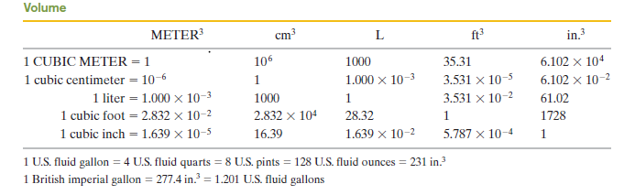

**3.5.2 Mass**

Quantities in the colored areas are not mass units but are often used as such. For example, when we write 1 kg “=” 2.205 lb, this means that a kilogram is a *mass* that *weighs* 2.205 pounds at a location where *g* has the standard value of 9.80665 m/s2.

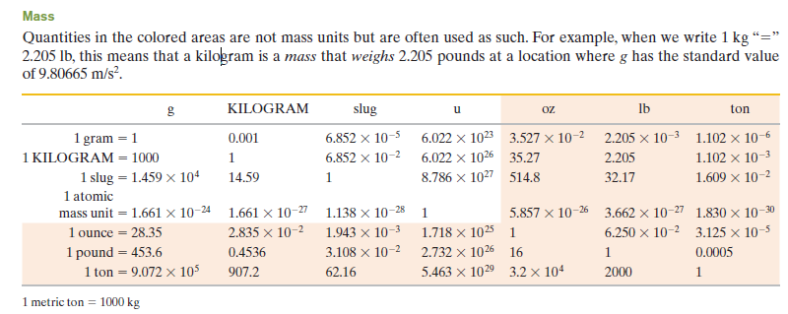

**3.5.3. Density**

Quantities in the colour areas are weight densities and, as such, are dimensionally different from mass densities. See the note for the mass table.

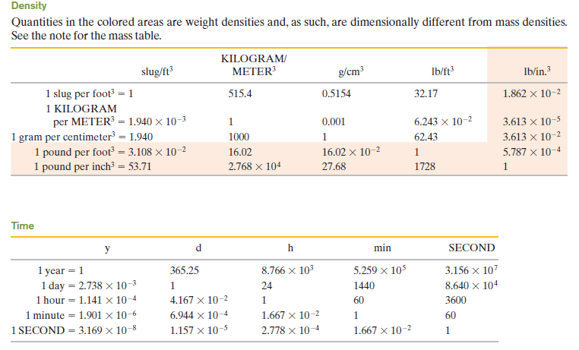

**3.3.4 Energy, Work, Heat**

Quantities in the coloured areas are not energy units but are included for convenience. They arise from the relativistic mass–energy equivalence formula *E* = *mc*2 and represent the energy released if a kilogram or unified atomic mass unit (u) is completely converted to energy (bottom two rows) or the mass that would be completely converted to one unit of energy (rightmost two columns).

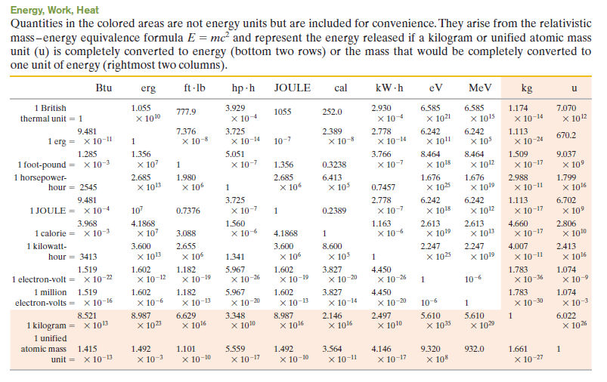

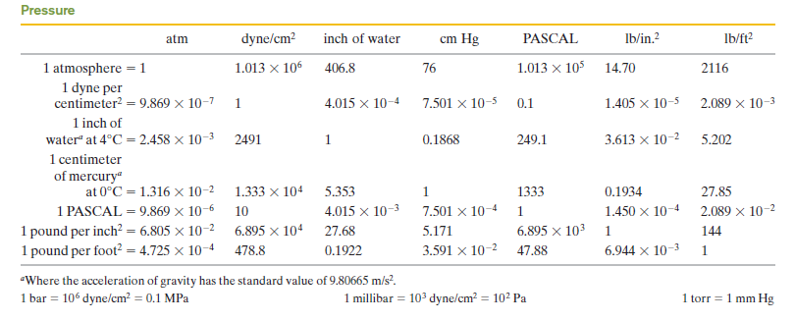

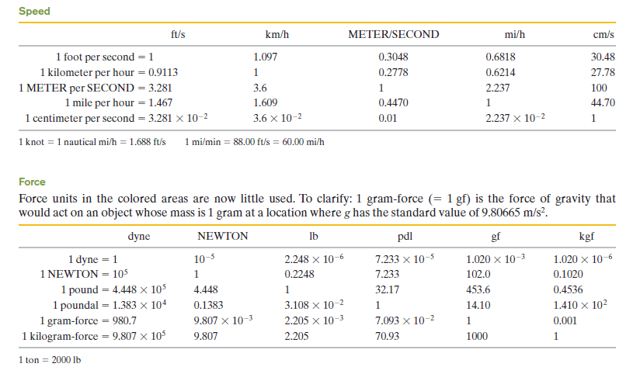

**3.5.5 Force**

Force units in the colored areas are now little used. To clarify: 1 gram-force (= 1 gf) is the force of gravity that would act on an object whose mass is 1 gram at a location where *g* has the standard value of 9.80665 m/s2.

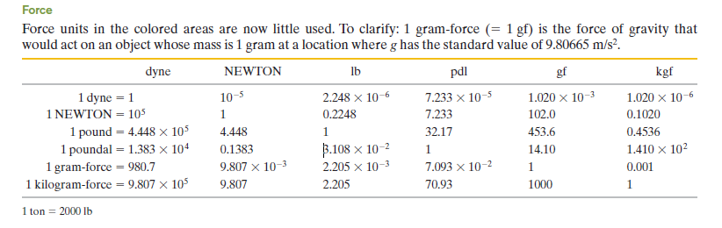

**Energy, Work, Heat**

Quantities in the colored areas are not energy units but are included for convenience. They arise from the relativistic mass–energy equivalence formula *E* = *mc*2 and represent the energy released if a kilogram or unified atomic mass unit (u) is completely converted to energy (bottom two rows) or the mass that would be completely converted to one unit of energy (rightmost two columns).

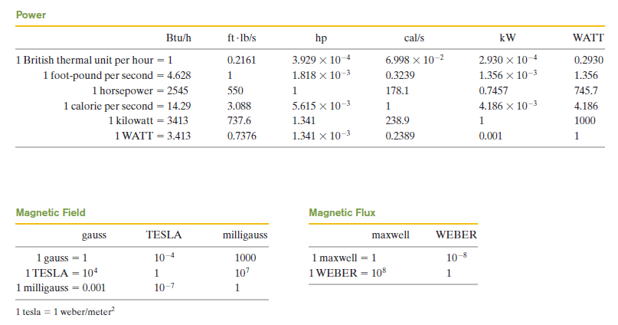

## 3.6 Dimension and Dimension Analysis

In this section, the **dimensions** of a quantity refer to the types of base units or base quantities that make it up. The dimensions of area, for example, are always length squared, abbreviated [*L*2], using square brackets; the units can be square meters, square feet, and so on. Velocity, on the other hand, can be measured in units of km/h, m/s, or mi/h, but the dimensions are always a length [*L*] divided by a time [*T*]: that is, [*L*/*T*].

The formula for a certain quantity may is not necessary the same in certain instances, but the dimensions stays the same. For example, the area of a triangle of base *b* and height *h* is , whereas the area of a circle of radius *r* is . Here in this example, the formulas for calculating the quantity, Area (A) are different in the two cases, but the dimensions of area are always [*L*2].

Dimensions is useful in working out relationships, a procedure referred to as **dimensional analysis**. One useful technique is the use of dimensions to check if a relationship is *incorrect*. Note that we add or subtract quantities only if they have the same dimensions (we don’t add centimeters and hours); and the quantities on each side of an equals sign must have the same dimensions. In numerical calculations, the units must also be the same on both sides of an equation. Table 4 gives the list of dimension formulae of some familiar physical quantities.

**Table 4:** Dimension formulae of physical quantities.

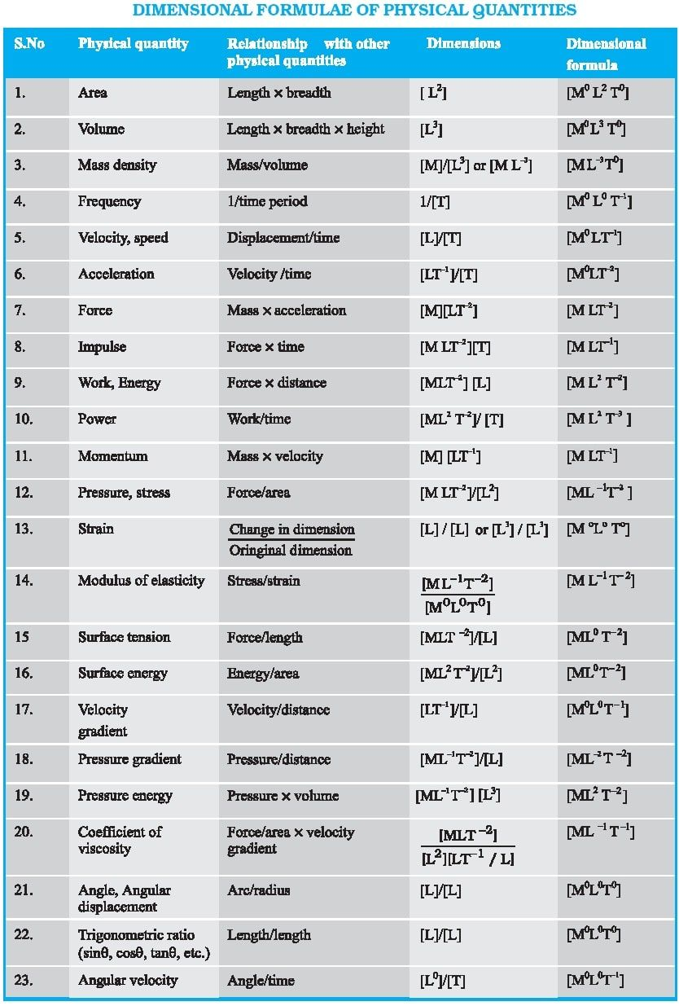

**Example 1**

For example, consider a simple pendulum of length. Suppose that you can’t remember whether the equation for the period *T* (the time to make one back-and-forth swing) is or , where *g* is the acceleration due to gravity and, like all accelerations, has dimensions [*L*/*T*2].

Whereas the latter (g/𝓁) is not:

The constant 2π has no dimensions and so can’t be checked using dimensions.

**Example 2**

Show on the basis of dimensional analysis that the relation is correct.

where P is the pressure difference between the two ends of the capillary; r its radius, its length, the rate of flow of liquid through it (volume per second) and is the coefficient of viscosity.

**Solution**

## From the relation

We have for the dimension of Right Hand Side (R.H.S)

The formula for viscosity is

Now, the dimension of Left and Side (L.H.S.),

**Summary**

In this unit you have learnt:

1. the base quantities in the SI system which are the length (m), time (s), mass (kg), electric current (A), temperature (K), amount of substance (mol) and luminous intensity (cd).
2. prefixes are used to compact very large or very small experimental measurements.
3. unit can be converted using chain-link method.
4. that derive unit are obtained by combination of base unit.
5. solving dimensional analysis problem involving approximate relationships between the physical quantities.

**Self-assessment**

1. Define the following (a) physical quantities (b) units (c) dimension
2. Why do you think it is important to have a standard for unit of a physical quantity
3. List seven (7) base quantities in the SI system and their corresponding units.
4. Differentiate between base and derived unit.
5. Supposing you derived an equation , where is the speed of an object after a time , is the object’s initial speed, and the object undergoes an acceleration *a*. Show that this equation is either correct or incorrect.

**Tutored Marked Assignments**

1. Using unit conversion, what is the number of seconds in 365 days?
2. Show on the basis of dimensional analysis that following relations are correct:

(a) , where u is initial velocity, is final velocity, a is acceleration of the body and S is the distance moved.

(b) where is the density of earth, G is the gravitational comstant, r is the radius of the earth and g is acceleration due to gravity.

**Reference**

Adams, Steve & Allday, Jonathan (2000). Advanced Physics. UK: Oxford University Press.

Giancoli, D. C. (2008). *Physics for scientists & engineers with modern physics* (Vol. 2). Pearson Education.

Goel , V. K. (2007). Fundamentals of Physics Xi, Tata McGraw-Hill Education

Halliday, D., Resnick, R., & Walker, J. (2013). *Fundamentals of physics*. John Wiley & Sons.

Keith, Gibbs (2011). Advanced Physics (Second Edition). Cambridge University Press.

Michael Browne (2013). Schaum's Outline of Physics for Engineering and Science: 788 Solved Problems + 25 Videos, McGraw-Hill Professional

Nelkon, M & Parker, P (1995) Advanced Level Physics. New Delhi, India: CBS Publishers & Distributors.

Roger Muncaster (1993). A-level Physics, Nelson Thornes

Serway, R. A., & Vuille, C. (2014). *College physics*. Cengage Learning.

Young, H. D., Freedman, R. A., Sandin, T. R., & Ford, A. L. (1996). *University physics* (Vol. 9). Reading, MA: Addison-Wesley.

**Further Reading**

**Unit 2:** Scalar and Vector I

1.0 Introduction

2.0 Learning Outcomes

3.0 Main Content

3.1 Definition

3.2 Vector Notation

3.3 Addition of vectors- Graphical method

3.3.1 Head to Tail Method

3.3.2 Parallelogram Method

3.4 Subtraction of Vector and Multiplication Vector by Scalar

3.5 Adding Vector by Components

3.6 Component method for adding vectors

4.0 Summary

5.0 Self-Assessment

6.0 Tutor Marked Assignment

7.0 References

8.0 Further Reading

**1.0 Introduction**

There exist many physical quantities in the natural word on a daily basis. For instance, we are familiar with physical quantities like length, mass, time, temperature, and velocity. We know that over time objects can accumulate mass. Objects have weight because of gravity. We exert force when we hold our pen to write. During harmattan season, we experience electric charge directly through electro static shock. The numbers of physical quantity in nature are numerous, and we can divide these quantities into two types called namely vector and scalars. In this unit, you will learn how to add and subtract vectors using different method such as graphical head to tail method, parallelogram method.

**2.0 Learning Outcomes**

When you have studied this unit, you should be able to:

1. explain the differences between vector and scalar
2. adding vectors using head-to-tail graphical method
3. add vectors by drawing them in parallelogram arrangements,
4. subtracting vector using head-to-tail graphical method.
5. calculate the components of a vector on a given coordinate system, showing them in a drawing.

**3.0 Main Content**

**3.1 Definition**

A **vector** has magnitude as well as direction, and vectors follow certain (vector) rules of combination, which we examine in this chapter. A **vector** **quantity** is a quantity that has both a magnitude and a direction and thus can be represented with a vector. Some physical quantities that are vector quantities are displacement, velocity, and acceleration. As you progress studying this course, you will see many more of examples of vector quantities are mentioned throughout this unit (section), so learning the rules of vector combination now will help you greatly in later module.

Not all physical quantities involve a direction. The following physical quantities for example, temperature, pressure, energy, mass, and time do not “point” in the spatial sense. We call such quantities **scalars,** and we deal with them by the rules of ordinary algebra. A single value, with a sign (as in a temperature of 40°F), specifies a scalar.

The simplest vector quantity is displacement, or change of position. A vector that represents a displacement is called, reasonably, a **displacement vector.**

**Scalar** is those physical quantities which possesses only magnitude and no direction in space such as temperature, time, volume and speed.

For complete description of a scalar quantity we need a unit and numeric value (magnitude) which states how many times the units is contained in that physical quantity. Thus, for example, when we speak of a temperature of the outer surface of the sun is approximately 6000 K, we mean that the unit of temperature Kelvin (K), is contained 6000 times in it.

**3.2 Vector Notation**

There are numerous ways of writing the symbol for vector. In this unit, vector will be written in a form of an arrow pointing to the right above it over an italic symbol. For example, force , weight and velocity , indicating that these vector quantities have both magnitude and direction.

Sometimes, we might only be interested in the magnitude (i.e. the numerical value) of a vector. In such a case, the arrow is omitted when writing the vector. For the case of the displacement vector:

* represents the displacement vector (which implies both properties of a vector, magnitude and direction.
* *D* represents the magnitude of the displacement vector.

In some other form, vector can be presented with a bold symbol

**3.3 Addition of vectors- Graphical method**

Vectors are added in special way because they have magnitude as well as direction. By implication simple arithmetic cannot be used for adding vectors if the vectors are not in the direction. But we can use simple arithmetic for adding vectors if they are in the same direction (one dimension).

**Example 1**

Suppose you set out for a daily exercise from your house (point of origin) and jog 8 km east on day one, and 6 km east the next day, you will be east of the point of origin. From Fig.1a, we will say that the net or resultant displacement is 14 km to the east.

On the other hand, if you jog 8 km east on the first day, and 6 km west (in the reverse direction) on the second day, then you will end up 2 km from the origin (Fig. 1b), so the resultant displacement is 2 km to the east. In this case, the resultant displacement is obtained by subtraction:

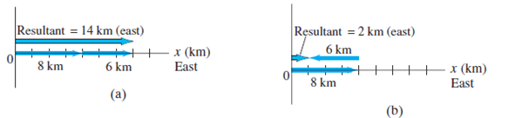

**Figure 1:** Combining vectors in one dimension.

**Example 2**

For example, suppose a particle moves 10 km east and then late moves 5 km along the north direction. From Fig. 2, we can draw these displacements on a graph in which the positive *y* axis points north and the positive *x* axis points east. On this graph, we draw an arrow, labelled , to represent the 10.0 km displacement to the east. Then we draw a second arrow, to represent the 5.0 km displacement to the north.

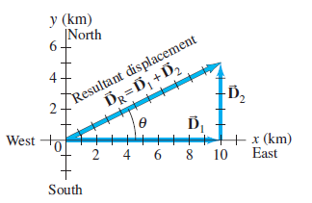

**Figure 2:** Combining vectors in two dimensions.

Let represent the resultant displacement by the arrow labelled in Fig. 2. Using Pythagoras theorem for the formed right triangle, we can calculated the magnitude of which is given as:

**3.3.1 Head to Tail Method**

Suppose we have two vector and given as

and

The vectors and implies that both properties of the vectors have magnitude and direction. The magnitude is the length of their respective vector lines and the direction is indicated to where the arrow point to.

The following procedure is suggested to geometrically sum the vectors.

1. On paper, sketch vector to some convenient scale and at the proper angle.
2. Sketch vector to the same scale, with its tail at the head of vector , again at the proper angle.
3. The vector sum or the resultant vector is the vector that extends from the tail of to the head of .

*Implementing the steps*

***Step 1:*** On paper, sketch vector to some convenient scale and at the proper angle.

***Step 2:*** Sketch vector to the same scale, with its tail at the head of vector , again at the proper angle.

***Step 3:*** The vector sum or the resultant is the vector that extends from the tail of to the head of .

The vector sum or the resultant of the vectors and can be presented by the relation

(1)

The plus sign (+) in the equation (1) and the “sum” and “add” have different meaning for vectors than in simple arithmetic because the involves the components of magnitude and direction.

Adding to is the same as adding to that is they are commutative

(commutative law), this implies that one can either start from item 1 or item 2 in the procedural step in summing vector presented above.

For the case of more than two vectors, we can group them in any order as we add them. For

**Example 3**

Finding the sum of these vectors

**Solution**

We shall be using the procedure stated above in summing these three vectors.

**Parallelogram Method**

**Parallelogram method** is another technique used to add two vectors. It is fully equivalent to the tail-to-tip method. In this method, the two vectors are drawn starting from a common origin, and a parallelogram is constructed using these two vectors as adjacent sides as shown in Fig.3b. The resultant is the diagonal drawn from the common origin. In Fig. 3a, the tail-to-head method is shown, and we can see that both methods yield the same result.

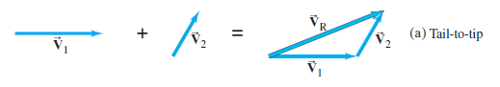

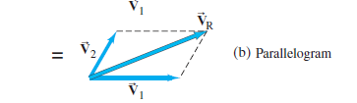

**Figure 3:** Vector addition by two different methods (a) Tail-to-head method (b). Parallelogram method.

**3.4 Subtraction of Vector and Multiplication Vector by Scalar**

Figure 4 shows the vector which have the same magnitude as but opposite in direction.

**Figure 4:** The vector and have the same magnitude and opposite direction.

However, there is nothing like negative vector. If so, then what is the meaning the negative sign in the vector ? You should know that the magnitude of all vectors is positive. Therefore, the answer to the question is that the minus sign indicate the direction of the vector.

**Example**

To construct the vector difference you can either place the tail of at the head of or place the two vectors and head to head.

**Solution**

The vector subtraction between the vectors is defined as

This implies that the difference between the two vectors is equal to the sum of the first vector plus the negative of the second. Thus we can apply the stated tail-to-head method procedure listed above to solve subtraction of one vector from another.

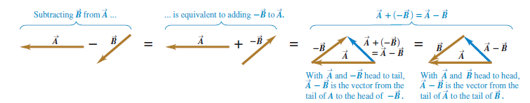

**3.5 Adding Vector by Components**

In the preceding section, we added vectors by using graphical method which can be tedious which is sometimes often not sufficiently accurate and is not useful for vectors in three dimensions. Adding vector by component is more robust and precise.

To define what we mean by the components of a vector we begin with a rectangular (Cartesian) coordinate system of axes (Fig. 5). The vector lies in a particular plane. It can be expressed as the sum of two other vectors, called the **components** of the original vector. The components are usually chosen to be along two perpendicular directions, such as the *x* and *y* axes. The process of finding the components is known as **resolving the** **vector into its components**. Figure 5 shows the vector and its x and y vector components, and , which have magnitudes.

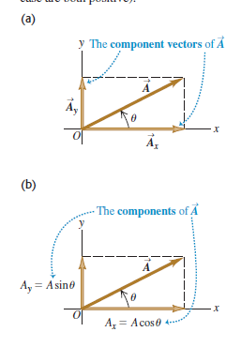

**Figure 5:** Representing a vector in terms of (a) component vectors and and (b) components and (which in this case are both positive).

We can find the components of in Fig. 5*a* geometrically from the right triangle there:

(2a)

(2b)

or equivalently

(3a)

(3b)

The equations 2-3 are obtained from the right angle triangle of Fig. 5 using trigonometric function angle , that is

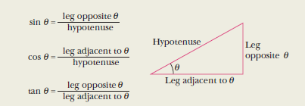

**Figure 6:** A triangle used to define the trigonometric functions.

The scalar *x*- component and *y*- component of the resultant is the algebraic sum of all the scalar components along the *x*- component and *y*- component. The magnitude of the resultant is given by

(4)

In two dimension, the angle of the resultant with x-axis can be found using the trigonometric function of (see Figure 6)

(5)

If there is also a *z*- components the resultant is given as

(6)

**Example**

The five coplanar forces shown in Fig. 8 act on an object. Find their resultant

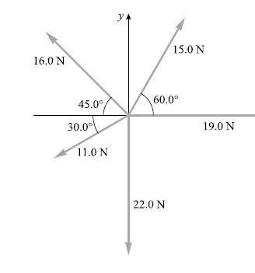

**Solution**

(1) The first thing to do is to resolve the vectors along *x*- and *y*-components of each force. These components are as follows:

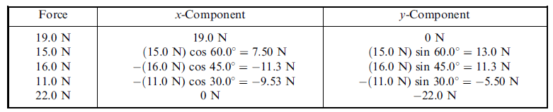

The + and – signs signify the direction.

(2) The resultant has components **,** and .**,** where we read and as “the sum of all the *x*-force components” and “the sum of all the *y*-force components”. We then have

= 19.0 N +7.50 N -11.3 - 9.53 N + 0 N = + 5.7 N

= 0 N +13.0 N +11.3 - 5.50 N -22.0 N = - 3.2 N

(3) The magnitude of the resultant is

(4) Finally, we sketch the resultant as shown in Fig. 9 and find its angle. We have

Then = 360° – 29° = 331°. The resultant, is 6.5 N at 331° (or -29°).

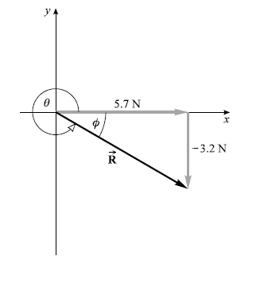

**Figure 7:** The resolution of resultant vector .

**Summary**

At the end of this unit, you have learnt

1. explain the differences between vector and scalar
2. how to add vectors using head-to-tail graphical method
3. how to add vectors using parallelogram method
4. the steps to take in subtracting vector using head-to-tail graphical method.
5. how to resolve a vector using the components of a vector on a given coordinate system.

**Self-Assessments**

(i). Classify the following physical quantities as a vectors or scalars

(a) length (b) force (c) speed (d) mass (e) temperature (f) velocity (g) time (h) height

**Figure 7:** Illustration of an example for adding vector using component method

**Tutor-Marked Assignments**

1. Find the x- and y-components of a 25.0 m displacement at angle of 210.0°

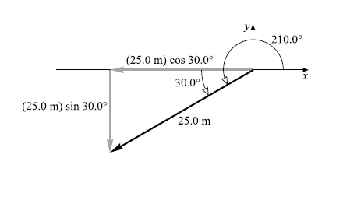

**Reference**

Adams, Steve & Allday, Jonathan (2000). Advanced Physics. UK: Oxford University Press.

Giancoli, D. C. (2008). *Physics for scientists & engineers with modern physics* (Vol. 2). Pearson Education.

Goel , V. K. (2007). Fundamentals of Physics Xi, Tata McGraw-Hill Education

Halliday, D., Resnick, R., & Walker, J. (2013). *Fundamentals of physics*. John Wiley & Sons.

Keith, Gibbs (2011). Advanced Physics (Second Edition). Cambridge University Press.

Michael Browne (2013). Schaum's Outline of Physics for Engineering and Science: 788 Solved Problems + 25 Videos, McGraw-Hill Professional

Nelkon, M & Parker, P (1995) Advanced Level Physics. New Delhi, India: CBS Publishers & Distributors.

Roger Muncaster (1993). A-level Physics, Nelson Thornes

Serway, R. A., & Vuille, C. (2014). *College physics*. Cengage Learning.

Young, H. D., Freedman, R. A., Sandin, T. R., & Ford, A. L. (1996). *University physics* (Vol. 9). Reading, MA: Addison-Wesley.

**Further Reading**

**Unit 3: Scalar and Vector II**

1.0 Introduction

2.0 Learning Outcomes

3.0 Main Content

3.1 Unit Vector

3.2 Introduction to Methods of Product of Vector and Scalar

3.2.1 Vector Product

3.2.2 Scalar Product

3.3 Calculating the Scalar Product Using Components

3.4 Calculating the Vector Product Using Components

4.0 Summary

5.0 Self-Assessment

6.0 Tutor Marked Assignment

7.0 References

8.0 Further Reading

**1.0 Introduction**

This unit is the concluding part of vector and scalar concept in elementary physics. In this unit, you will learn the fundamental unit vector, how to find the product of vector and scalar variables.

**2.0 Learning Outcomes**

When you have studied this unit, you should be able to:

* explain unit vector
* calculating of scalar product
* calculating of vector product

**3.0 Main Content**

**3.1 Unit Vector**

A **unit vector** is a vector that has a magnitude of 1, with no units. Its only purpose is to *point*—that is, to describe a direction in space. Unit vectors provide a convenient notation for many expressions involving components of vectors. We will always include a caret or “hat” in the symbol for a unit vector to distinguish it from ordinary vectors whose magnitude may or may not be equal to 1. The special unit vectors , , and are assigned to the *x*-, *y*-, and *z*-axes, respectively.

Using Fig. 1, we can write a vector in terms of its components as

(1)

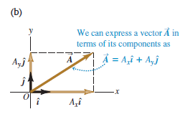

**Figure 1:** Expressing a vector in terms of its components.

If the vectors do not all lie in the *xy*-plane, then we need a third component. We introduce a third unit vector that points in the direction of the positive *z*-axis (Fig. 2). Then the unit vector becomes

(2)

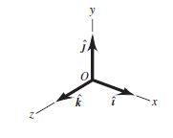

**Figure 2:** The unit vectors , , and

**Example 1**

Given the two displacements

and find themagnitude of the displacement

**Solution**

We are ask to multiply the vector by 2 (a scalar) and to subtract the vector from the result in order to obtain .

m

The magnitude of is

**3.2 Introduction to Methods of Product of Vector and Scalar**

**3. 2.1 Vector Product**

There are many physical relationships that can be expressed by using *products* of vectors. Just like the addition and subtraction of a vector, you cannot perform simple ordinary multiplication of vector because vectors are not ordinary numbers. There are two types of products of vectors. The first to be discussed is called the *scalar product while the* second type is called the *vector* *product*.

**3.2.2 Scalar Product**

The **scalar product** of the two vectors and in Fig. 12a is denoted by . The scalar product is also called the **dot product.**

Fig. 4b shows the projection of the vector onto the direction of Thus, is defined as the magnitude of multiplied by the component of in the direction of We can expressed it in equation as

(3)

Alternatively, can as well be defined as the magnitude of multiplied by the component of in the direction of as shown in Fig 4c.

Hence, for two vectors and ,

This implies that the scalar product obeys the commutative, so we can write

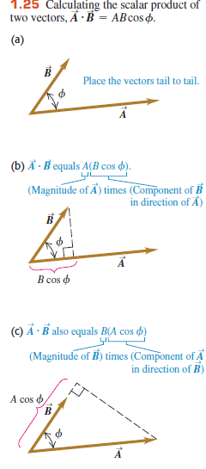

**Figure 3:** Calculating the scalar product of two vectors,

**3.3 Calculating the Scalar Product Using Components**

If we know the *x-,y*-, and *z*- components of and , the scalar product of the vectors can be work out.

Let first calculate the scalar product of the unit vectors , , and which have magnitude equals to one and are perpendicular to each other.

Using equation (3), we get

(4)

We can write the vectors and in terms of *x-,y*-, and *z*- components:

(5)

Making reference to equation (4), we find out from equation (5) that of the nine terms, six terms is zero, and the remaining three terms gives

(6)

From equation (6), we can conclude that the scale product of two vectors is the sum of the products of their respective components.

**Example 2**

Find the scalar product of the two vectors and given in Fig. 4. The magnitude of the

vectors are given as and

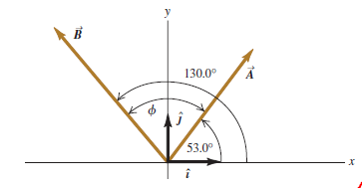

**Figure 4:** Two vectors and in two- dimensions

**Solution**

We can solve this problem using two method already learnt in the preceding section

(i) We can calculate the scalar product of by the magnitude of the two vectors and the angle between them using equation (3).

(ii) Resolving the components of the vectors using equation (6).

*First Method*

The angle between the two vectors is calculated as the difference between the angles that the respective vector components makes with the *x*-axis

Using equation (9)

*Second Method*

We begin by finding the components of the vectors. The angles of the vector and are given with respect to the positive x-axis and are measured from +*x*-axis to +*y*-axis.

Recall equations (2) in Unit 2,

We have,

Using equation (6),

Notice that the first and second methods give the same result.

**3.4 Calculating the Vector Product Using Components**

The **vector product** of two vectors say and is written as which produces another vector whose magnitude is

(7)

where Φ is the angle between the vectors and . The vector notation is also known as **cross product** and is pronounced as “A cross B”.

= 0 if the vectors and are parallel or antiparallel. However, when and are perpendicular to each other, their magnitude is maximum and is written as .

The direction of the cross product of is determined using the **right-hand rule.** The direction of is perpendicular to the plane containing the vectors and .

**Steps to follow when using vector** **right-hand rule**

1. Place the vector and tail to tail

2. Point the fingers of right hand along the vector , with palm facing .

3. Then curl the fingers towards .

4. Thumb points in the direction of as demonstrated in Figure 14a.

(a)

(b)

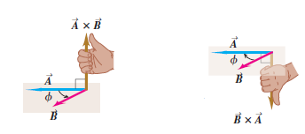

**Figure 5:** The vector product of (a) and (b) determined using the right-hand rule.

You can see from Fig. 14 that vector product of and are anticommutative meaning that that both has the same magnitude but opposite in direction. Thus the order of the vector product is important. For the case of from Fig. 14b, the right-hand fingers are pointed along the vector and the palm is facing . The fingers then sweep into .

= (anticommutative)

(8)

Once we know the vector components of and , we can determine the components of the vector product in a similar way to that of the scalar product.

From Fig. 2, you can see that the unit vectors , , and are perpendicular to each other. Therefore, the vector product of any vector with itself is zero, thus

Using equations (7) and (8) and the right-hand rule, we get the following vector product from Fig. 2

(9)

We can then write the vector and in terms of their components and the corresponding unit vectors, and this allows us to expand cross vector product as:

This can be rewritten as

(10)

Evaluating equation (10) using the vector product multiplication table for the unit vectors in equation (9), we have

We can then collect the like times by grouping the terms, we have

(11)

If , then the components of is given by

(12)

The vector product can also be expressed in determinant form as

To solve the vector product of , we follow the following steps:

**Step 1:** Cover the first column of the matrix and draw the two arrows like so;

We have the first components as

**Step 2:** Uncover the first column and now cover the second column to have the second componets of the vector product,

**Step3:** We now cover the last column to get the third vector componets as,

The vector has a componet along the *x*-,*y*- and *z*-axis, that is . Therefore, the vector product of is given as

(13)

After using the two methods, you can see that the equations (11) and (13) are the same. The choice of the method to use is based on your convenience.

**Example 3**

Given two vectors and . Determine the value of

**Solution**

Using steps 1 to 3 for solving determinant vectors, we have

**Summary**

After completing reading this unit, you have learnt

* That unit vector is important in describing the components of vectors.
* Methods and step to take for calculating of scalar product
* Methods and step to take for calculating of vector product

**Self- Assessments**

1. The vector product of any vector with itself is equals to what?

2. The scalar product of any scalar with itself is equals to what?

3. Given two vectors and . Determine the value of .

**Tutor Marked Assignment**

Suppose a patient has a dislocation on his shoulder and is put into a traction apparatus as shown in Fig. xxx. The force of pulls and both have equal magnitudes and their sum produce an outward traction force of 5.60 N on the patient’s arm. How large should these pulls be?

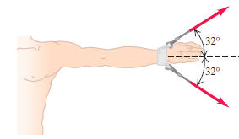

Figure 15: Traction force

**Reference**

Adams, Steve & Allday, Jonathan (2000). Advanced Physics. UK: Oxford University Press.

Giancoli, D. C. (2008). *Physics for scientists & engineers with modern physics* (Vol. 2). Pearson Education.

Goel , V. K. (2007). Fundamentals of Physics Xi, Tata McGraw-Hill Education

Halliday, D., Resnick, R., & Walker, J. (2013). *Fundamentals of physics*. John Wiley & Sons.

Keith, Gibbs (2011). Advanced Physics (Second Edition). Cambridge University Press.

Michael Browne (2013). Schaum's Outline of Physics for Engineering and Science: 788 Solved Problems + 25 Videos, McGraw-Hill Professional

Nelkon, M & Parker, P (1995) Advanced Level Physics. New Delhi, India: CBS Publishers & Distributors.

Roger Muncaster (1993). A-level Physics, Nelson Thornes

Serway, R. A., & Vuille, C. (2014). *College physics*. Cengage Learning.

Young, H. D., Freedman, R. A., Sandin, T. R., & Ford, A. L. (1996). *University physics* (Vol. 9). Reading, MA: Addison-Wesley.

**Further Reading**

**Module 2: Particle Kinematics in Two Dimensions**

**Unit 1: One-Dimensional Rectilinear Motion**

1.0 Introduction

2.0 Learning Objectives

3.0 Main Content

3.1 Particle Kinematics

3.2 One – Dimensional Rectilinear Motion

3.3 Average Velocity and Average Speed

3.3.1 Instantaneous Velocity and Instantaneous Speed

3.4 Acceleration

3.4.1 1-D Motion under Uniform Acceleration

3.5 Free – Fall Acceleration

3.6 Two and Three – Dimensional motion

3.6.1 Position and Displacement

3.6.2 Average velocity and instantaneous velocity

3.6.3 Average acceleration and instantaneous acceleration

4.0 Summary

5.0 Self-Assessment

6.0 Tutor Marked Assignment

1. Reference
2. Further Reading

1.0 **Introduction**

This unit will focus on description of motion in one, two and three dimensions of objects without referring to the causes of the motion.

**2.0 Learning Objectives**

By the end of this note, you should be able to:

* explain kinematics
* solve problems relating to displacements, velocities and accelerations of a particle
* solve problems relating to rise and fall of an object under constant acceleration

**3.0 Main Content**

**3.1 Particle Kinematics**

Particles may be described as point-like objects with mass but no size i.e. they exhibit negligible size and internal structure while kinematics can be defined as the branch of mechanics which deals with the mathematical description of motion of a particle and rigid bodies in space without referring to the forces and torques causing the motion. The concept of motion has a relative character such that if a rigid body moves with respect to one another and the distances between the two bodies changes, then one may need to investigate the geometrical properties of motion of the rigid bodies with respect to their position and time by using relationships between kinematics variables which are given in Table 1 below. Figure 1 shows various simple coordinate systems where the position vector *r* will have different forms in different coordinate systems but the velocity *v* and acceleration *a* still retains the same definition.

**Table 1:** Kinematic variables



**Figure 1:** Simple coordinate systems

In this section, we shall be concerned with the study of one-dimensional straight line motion of a particle and its generalization to two- and three-dimensional motion.

**3.2 One-Dimensional Rectilinear Motion**

A rectilinear motion is the motion of a particle along a straight line. It may, for example, be the motion of a ball rolling across the floor, the motion of a car on a straight road, the motion of a ball tossed straight up or that of an object dropped from a height. Figure 2 shows a ball rolling on an axis that is marked in units of length (in this case meter) and can extend indefinitely in opposite directions.

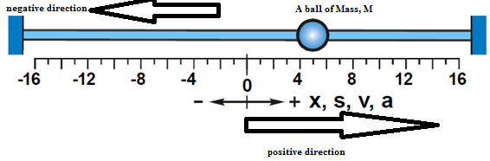

**Figure 2:** Rectilinear motion coordinate system of a ball.

Consider a particle moving from an initial position to a final position along a straight line, the change in position is



Equation 2.1 is equal to the **distance** covered by the particle. If the direction of motion is specified along with the magnitude ΔX, then the change in position is a vector quantity referred to as the **displacement**.

If the corresponding initial time  at the start of the motion and the final time are noted, then the time interval for the duration of the motion is given by 

Therefore, the ratio therefore defines the **speed** of the particle. If the direction is specified then the ratio is referred to as the **velocity**. In summary, *speed* is the rate of change of distance covered with time, and *velocity* is the rate of change of displacement with time.

When the rate of change of *distance* covered (or *displacement*) with time is constant the *speed* (*velocity*) is said to be **uniform**. This means that the particle travels equal distance in equal time interval.

Similarly the rate of change of the velocity of a particle, say from an initial value *u* to a final value *v* over a time interval Δt, defines the **acceleration** of the particle i.e.



**3.3 Average Velocity and Average Speed**

Average velocity *vavg* is defined as the ratio of the displacement ΔX which occur during a particular time interval i.e.



On the other hand, average speed is defined as the ratio of the total distance covered with time i.e.



**3.3.1 Instantaneous Velocity and Instantaneous Speed**

Instantaneous velocity can be defined as the velocity of the particle at any instant and it can be obtained from the average velocity by shrinking the time interval change in time closer and closer to zero. Therefore, as the change in time dwindles, the average velocity approaches a limiting value, which is the velocity at that instant.



Speed on the other hand is the speed of the particle at an instant or a particular time

**3.4 Acceleration**

When the velocity of particle changes, we say the particle is said to undergo acceleration. For a motion of an object along an axis, the average acceleration *aavg* over a time interval is given as:



Therefore, instantaneous acceleration can be defined as the rate at which its velocity is changing at that instant i.e.



Substituting equation 2.5 into equation 2.7, we will have



**3.4.1 1-D Motion under Uniform Acceleration**

A particle undergoing a uniform acceleration is moving at constant rate of change of velocity with time. When acceleration of a particle is constant, the average and instantaneous acceleration are equal and it can be said that positive acceleration is associated with increasing velocity, while negative acceleration or **deceleration** refers to a decreasing velocity.

Consider a uniformly accelerated particle whose velocity changes from an initial velocity, *u* to a final velocity, *v* over a time interval *t*, the acceleration of the particle is given by



Equation 2.9 can be rewritten as:



Note that *u* is the velocity at time *t = 0,* *v* is the velocity at any later time *t*. In a similar manner equation 2.3 can be rewritten (with view changes in notation) as



Then as



In which *x0* is the position of the particle at *t = 0*, and *vavg* is the average velocity at beginning of the interval (i.e u, at *t = 0*,) and the velocity at the end of the interval (i.e. *v*, at a later time *t*) then, the average velocity is given as:



Substituting the right hand side of equation 2.10 for *v*, into equation 2.13 yields



and finally substituting equation 2.14 into equation 2.12 becomes



Combining equations 2.10 and 2.15 by eliminating *t*, we obtain



Equation 2.16 is useful when time t is not required to be obtained. Also, we can eliminate acceleration *a* from equations 2.10 and 2.15 which gives



And finally, initial velocity, *u* can be eliminated such that we are going to have



Equations 2.10, 2.15 and 2.16 – 2.18 are known Newton’s equations of motion which can be used to solve problems involving motion of a particle under constant acceleration and they are summarized in the Table 2.

**Table 2: Equations of motion under constant acceleration**

|  |  |  |
| --- | --- | --- |
| **S/No.** | **Equations** | **Missing Quantity** |
| 1 |  |  |
| 2 |  | *V* |
| 3 |  | *T* |
| 4 |  | *A* |
| 5 |  | *U* |

**Example 1**

A car starts from rest and travels 0.25 km in 25 s at constant acceleration. (a) Calculate the acceleration of the car. (b) Determine the final speed of the car.

**Solution**

From the question, the car starting from rest implies that *u* = 0, distance covered is 0.25 km = 250 m, time interval *t* = 25s. We are required to calculate the final velocity *v* and acceleration *a* using the equation that does not contain the final velocity *v*. Therefore



where *S* is the distance covered. So making acceleration *a* the subject of formula, then it becomes



For the final velocity, we use the equation



**Example 2**

A bus travelling at 40 km/hr accelerates uniformly at 5 m/s2. Calculate its velocity after 2 minutes.

**Solution**

From the question, the bus is moving with an initial velocity of 40 km/hr which must be converted to m/s. therefore,

Initial velocity, *u* = 40 km/hr = 

Time, *t* = 2 minutes = 120 sec.

Therefore, using the equation implies 

**3.5 Free – fall Acceleration**

If an object is thrown up or down and we eliminate the effect of air on its flight, the object accelerates downward at a certain constant rate. This rate is called the free –fall acceleration and its magnitude is represented by *g*. The acceleration is independent of the object’s characteristics such as mass, density or shape. This means that *g* is the same for all objects. The value of *g* varies slightly with latitude and elevation. The value of *g* is taken to be 9.8 m/s2.

All the equations of motion under constant acceleration (i.e. equations 2.10, 2.15 and 21.6 – 2.18) also applies to free fall near the earth’s surface, this is shown in Table 3.

Note that the direction of motions are now along a vertical *y* axis instead of the *x* –axis.

Suppose an object is thrown upward with an initial positive velocity *u*, the acceleration *a* = - *g* and by the time the object gets to it maximum height, the final velocity becomes zero. On the returns of the object back to the ground, the initial velocity *u* is zero, acceleration *a* = + *g* and the final velocity has its value on hitting the ground surface.

**Table 3: Equations of motion under Free – fall acceleration**

|  |  |
| --- | --- |
| **S/No.** | **Equations** |
| 1 |  |
| 2 |  |
| 3 |  |
| 4 |  |

**Example 3**

An object is released from a height above the ground, obtain its final velocity after 5 seconds (take *g* = 9.8 m/s2)

**Solution**



**Example 4**

A stone is thrown vertically upward with an initial velocity of 40 m/s. calculate (a) the velocity after 3 sec (b) the maximum height attained and the time taken to reach it (c) the total time taken for the ball to return to the ground

**Solution**

(a) 

(b) 













(c) The total time taken for the ball to return to the ground.

If the time it takes to reach the maximum height is 4sec, then the total time will be 2*t* = 24 = 8 seconds

**3.6 Two and Three – Dimensional motion**

In this section, we are going to extend the motion treated under one dimensional space to two or three dimensions and many of the ideas used previously in section 3.1 such as position, velocity and acceleration are used here also but in a little more complex because of the extra dimensions.

**3.6.1 Position and Displacement**

In other to locate a particle, one needs to find its position vector,which is a vector that extends from a reference point to another point. In a unit-vector notation  can be written as



where *x*, *y*, *z* are components and *i*, *j*, *k* are unit vectors. For example, the positioncan be written as



As particle moves, its position vector changes. If the position vector changes, say for example from to during a certain time interval, then the particle’s displacement during the time interval is



Using the unit vector notion



**Example 5**

The position vector for a particle was initially given  and later. What is the particle’s displacement from to ? **Solution**



**3.6.2 Average velocity and instantaneous velocity**

Also, average velocity and instantaneous velocity can be written as



Instantaneous velocity



The equation can be simplified as



where the component of V are



**Example 6**

The position of a particle moving on an *x*-axis is given by where *x* is in meters and *t* is seconds. What is the velocity at *t* = 3.5 s?

**Solution**



At t = 3.5s,



**3.6.3 Average acceleration and instantaneous acceleration**

When the particle velocity changes from to in time interval, its average acceleration during this time becomes



Also, instantaneous acceleration *a*, at that interval is



The components of  are,,

**Example 7**

A particle’s position on the x-axis is given by with *x* in meters and *t* in seconds. What is the (a) particle’s velocity (b) acceleration?

**Solution**



**4.0 Summary**

In this unit, you have learnt

* that kinematics deals with the description of motion without considering the force causing the motion.
* solving problems relating to displacements, velocities and accelerations of a particle in one and multiple dimensions
* solving problems relating to rise and fall of an object under constant acceleration

**5.0 Self-Assessment**

1. Define the following terms: (i) particle (ii) kinematics

2. Differentiate between the following terms

(i) distance and displacement (ii) speed and velocity

3. A man sitting on the ground throws a ball vertically upward with an initial speed 30 m/s. (a) How long does it take the ball to return to the ground? (b)What is its velocity on striking the ground?

**6.0 Tutor Marked Assignment**

1. A particle with velocity at t = 0 undergoes a constant acceleration a of magnitude 3.0 m/s2 at an angle of 1300 from the positive direction of the x –axis. What is the particle’s velocity at t = 5.0s

2. An object moving with an initial velocity of 30 m/s accelerates uniformly at a rate of 10 m/s2 until it attains a velocity of 50 m/s. What is the distance covered.

3. A car accelerates uniformly at a rate of 10 m/s2 from an initial velocity of 36 km/hr for 30 sec. calculate the distance covered during this period.

**7.0 Reference**

Adams, Steve & Allday, Jonathan (2000). Advanced Physics. UK: Oxford University Press.

Giancoli, D. C. (2008). *Physics for scientists & engineers with modern physics* (Vol. 2). Pearson Education.

Goel , V. K. (2007). Fundamentals of Physics Xi, Tata McGraw-Hill Education

Halliday, D., Resnick, R., & Walker, J. (2013). *Fundamentals of physics*. John Wiley & Sons.

Keith, Gibbs (2011). Advanced Physics (Second Edition). Cambridge University Press.

Michael Browne (2013). Schaum's Outline of Physics for Engineering and Science: 788 Solved Problems + 25 Videos, McGraw-Hill Professional

Nelkon, M & Parker, P (1995) Advanced Level Physics. New Delhi, India: CBS Publishers & Distributors.

Roger Muncaster (1993). A-level Physics, Nelson Thornes

Serway, R. A., & Vuille, C. (2014). *College physics*. Cengage Learning.

Young, H. D., Freedman, R. A., Sandin, T. R., & Ford, A. L. (1996). *University physics* (Vol. 9). Reading, MA: Addison-Wesley.

**8.0 Further Reading**

**Unit 2: Projectile**

1.0 Introduction

2.0 Learning Objectives

3.0 Main Content

3.1 Projectile Motion

3.2 Total Time of Flight

3.3 Maximum Height

3.4 Horizontal Range

4.0 Summary

5.0 Self-Assessment

6.0 Tutor Marked Assignment

7.0 Reference

8.0 Further Reading

**1.0 Introduction**

This unit will focus on description of motion along a parabola without referring to the causes of the motion.

**2.0 Learning Objectives**

By the end of this note, you should be able to:

* explain projectile motion with a sketch of the path taken
* explain the magnitudes and directions of the velocity and acceleration components during the flight
* solve problems relating projectile motion

**3.0 Main Content**

**3.1 Projectile Motion**

Let us consider a special case of two dimensional motion i.e. a particle moving in a vertical plane with some initial velocity  but its acceleration is always the free-fall acceleration *g*, which is downward. Such a particle is called a projectile, meaning that it projected or launched and its motion is called projectile motion.

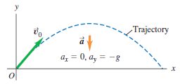

**Figure 1:** The trajectory of an idealized projectile.

Consider a projectile launched with an initial velocity which can be written as



And the components and can be found if the angle between  and the positive *x* direction is known such that  and 

During the motion, the projectile’s position vector and velocity vector change continuously, but its acceleration vector  is constant and always directed vertically downward. The projectile has no horizontal acceleration.

In projectile motion, the horizontal motion and the vertical motion are independent of each other, i.e. neither motion affects the other.

**3.2 Total Time of Flight**

The time taken for projectile to return to its initial level, that is at this point equation 2.29 becomes 



**3.3 Maximum Height**

Time taken to reach maximum height *H or Ymax* is T therefore equation 2.32 becomes



From equation 2.31, the maximum height becomes



Replace T by  and Y0 with zero

So that equation 2.34 will becomes



**3.4 Horizontal Range**

To obtain the horizontal range R, we multiply the total time of flight t with the horizontal component of velocity.



But





But 



At maximum, θ = 45,



**Example 1**

A projectile is fired with initial velocity of 100 m/s at an angle 300 to the horizontal. Calculate (a) the time of flight (b) Maximum height (c) the range

**Solution**



**Example 2**

A particle is projected with a velocity of 196 ms-1, at an elevation of 30°, find (i) the maximum height attained; (ii) the time of flight and the range on a horizontal plane through the point of projection; (iii) the velocity and direction of motion at a height of 130 m.

**Solution**

The initial horizontal velocity = 196 cos 30° = 98 ms-1

The initial vertical velocity = 196 sin 30° = 98 ms-1

(i) If *h* be the maximum height, then a this height the particle has lost all vertical velocity,

(ii) If *t* be the time of flight the vertical height at the time is zero,

The range is the distance travelled horizontally in 20 s with uniform velocity 98 ms-1.

Horizontal distance

(iii). If is the vertical velocity at height of 130 m

ms-1

**4.0 Summary**

In this unit, you have learnt

* that a projectileis anybody that is given an initial velocity and then follows a path determined entirely by the effects of gravitational acceleration and air resistance.
* how to sketch a typical path taken by a projectile motion
* deriving the formula for calculating the magnitudes and directions of the velocity and acceleration components during the flight
* solving problems relating projectile motion

**5.0 Self-Assessment Questions**

1. A stone is thrown vertically upward with an initial velocity *u* m/s. When it reaches a maximum height, it returns to the ground. Obtain an expression for (a) the maximum height (b) the velocity on hitting the ground.

**6.0 Tutor Marked Assignment**

**1.** A particle is projected out to sea with a velocity of 49 m/s from the top of a cliff 98 m high at an angle of 30° with the horizontal. Find how far from the bottom of the cliff the particle hit the water.

**7.0 Reference**

Adams, Steve & Allday, Jonathan (2000). Advanced Physics. UK: Oxford University Press.

Giancoli, D. C. (2008). *Physics for scientists & engineers with modern physics* (Vol. 2). Pearson Education.

Goel , V. K. (2007). Fundamentals of Physics Xi, Tata McGraw-Hill Education

Halliday, D., Resnick, R., & Walker, J. (2013). *Fundamentals of physics*. John Wiley & Sons.

Keith, Gibbs (2011). Advanced Physics (Second Edition). Cambridge University Press.

Michael Browne (2013). Schaum's Outline of Physics for Engineering and Science: 788 Solved Problems + 25 Videos, McGraw-Hill Professional

Nelkon, M & Parker, P (1995) Advanced Level Physics. New Delhi, India: CBS Publishers & Distributors.

Roger Muncaster (1993). A-level Physics, Nelson Thornes

Serway, R. A., & Vuille, C. (2014). *College physics*. Cengage Learning.

Young, H. D., Freedman, R. A., Sandin, T. R., & Ford, A. L. (1996). *University physics* (Vol. 9). Reading, MA: Addison-Wesley.

**8.0 Further Reading**

**Module 3: Force and Motion**

**Unit 1: Dynamics Newton’s Law of Motion**

1.0 Introduction

2.0 Learning Objectives

3.0 Main Content

3.1 Newton’s first law of motion

3. 2 Newton’s second law of Motion

3.3 Newton’s third law of Motion

4.0 Summary

5.0 Self-Assessments Questions

6.0 Tutor Marked Assignments

7.0 References

8.0 Further Reading

**1.0** **Introduction**

This unit will focus on descriptions of Newton’s laws motion, friction, work and Energy.

**2.0** **Learning Objectives**

By the end of this note, you should be able to:

* state Newton’s laws of motion;
* solve problems relating to the Newton’s laws of motion;

**3.0 Main Content**

**3.1 Newton’s First Law of Motion**

Newton’s first law of motion law states that: “every object will continue in its state of rest, or of uniform motion in a straight line, unless an external force acts on it”. But it is possible to apply a force to an object (i.e. external force acting on an object) without producing motion. A good example of this is when a car is to be pushed to start the engine by gradually increasing the applied force. It will get to a particular value of the applied force that the car will start to move, that is any values of the applied force below this value is not strong enough to cause the car to move. Therefore it can be said that though an external force is applied, there is no movement or change of state of the car.

, then

**Figure 1:** Applied force is equal to the frictional force between the box of mass *m* and the surface, only when acceleration .

Our basic assumption here, for now, is that there is no friction between the surfaces (i.e. the object and the horizontal plane) in contact. The explanation above is to introduce a new concept called **net force**, , to replace the external force . Therefore we can state the Newton’s first law of motion as follow:

“Every object will continue in its state of rest, or of uniform motion in a straight line, unless a net force acts on it.” The tendency of an object to resist change of state of motion is called inertia.

**Inertia:** the resistance an object has to a change in its state of motion.

**If then statement of the 1st law.**

Consider an object of mass *m* under the influence of three forces as shown in Fig. 2, the net force is the vector sum of all the three forces.

+ *x-axis*

+ *y-axis*

**Figure 2:** A box of mass *m* under the influence of three forces

Remember that a vector, can expressed as

where V= magnitude of the vector and = angle the direction of the vector makes with the positive x-axis.

**Figure 3:** Vector components of three forces

Y-component of vector ,

(1)

X-component of vector ,

(2)

**Example 1**

Determine angle (i.e. the angle each vector makes with the positive *x*-axis) for vectors shown in Fig. 4.

*+ x-axis*

*+ y-axis*

**Figure 4:** Resolving vector components

**Solution**

The direction of vector , as indicated the diagram, is along the positive *x*-axis

Therefore, the angle makes with the positive *x-axis* .

The direction of vector , as indicated in the diagram, is along the positive *y-axis*, and the angle between the positive *y-axis* and positive *x-axis* is .

Therefore, the angle makes with the positive *x-axis* .

For vector , the angle that makes with positive *x-axis* is ,

therefore .

**Example 2**

Using Fig. 4, if the magnitude of vectors is 10 N, 15 N and 20 N respectively, calculate the *y-* and *x-*components of each of the vectors.

**Solution**

Vector , magnitude of the vector .

Using equations (1) and (2), we have

*x-component* , and

*y-component*

For , magnitude = 15N, = 900

= 15 cos900 = 0N *x* – component

= 15 sin900 = 15N *y* - component

For , = 20N, = 2050

= 20 cos2050 = 20 x (-0.9063) = - 18.13 N *x* – component

= 20 sin2050 = 20 x (-0.4226) = - 8.45 N *y* – component

**Note:** If the direction of a vector is along *x-axis* or *y-axis*, the vector will have only one component e.g. is along *y-axis*, = 15N while = 0N.

Now to in Fig. 2, we can write each of the forces in a vector equation and the net force will be the vector sum of all the three forces.

+

+

**3.2 Newton’s Second Law of Motion**

The net force on a body is equal to the product of the body’s mass (*m*) and its acceleration.

= (3)

can also be written in form of its components;

(3b)

The implication of equation (3b) is that *x*-component of the resultant or net force is responsible for acceleration along *x-axis* while *y*-component is responsible for acceleration along *y-axis*. A good illustration of this is shown in Fig. 5.

*m*

box

**Figure 5:** Resultant force causingacceleration along *x-axis* and *y*-component

If the value of the applied or net force, in this case *F*, is gradually increased from zero upward, it will get to a particular value of at which the box will be lifted (or just about to be lifted) off the surface. At this value of , in the direction shown, the *y*-component (i.e. ) is equal to the weight of the box. To keep the box moving along the horizontal surface, the applied force needs to be reduced.

Therefore, from this illustration, the *x*-component of the net-force will drag the box along the horizontal surface while the *y*-component will try to lift the box off the surface.

We can also state the Newton’s second law of motion as: “The effect of a net force is to change the state of motion of the object on which it acts”.

**Example 3**

Find the magnitude and direction of the net force acting on the object shown in Fig. 6.

*m*

+ *y-axis*

+ *x-axis*

**Figure 6:** Resolving forces of along three directions.

**Solution**

,

,

,

=

The net force

=

+

+

=

The magnitude of ,

Angle that makes with positive *x-axis*,

The magnitude which indicates direction = 42.30°.

**Example 4**: If the mass of the object in Fig. 6 is 15 kg, find the acceleration (in magnitude and direction).

**Solution:**

= , From example 3,

Therefore,

Magnitude of ,

The angle , makes with positive x-axis,

The magnitude of acceleration , and

**Alternative Solution:** From = , the direction of the net force is the direction of the resulting acceleration. For the magnitude of acceleration, one can divide the magnitude of net force Fnet by the mass i.e.

**3.2.1 Momentum**

Force is equal to the rate of change of momentum,

(4)

where *dp* is change in momentum and *t*, the time for the change. Equation (4), means that the force acting on a body in motion is equal to the rate of change of momentum of the body.

Suppose an external force *F* acts on an object of mass m moving with initial velocity to change its velocity to at time interval *t*.

Then,

But =

=

**3.3 Newton’s Third Law of Motion**

When two objects interact, the forces on the objects from each other are always equal in magnitude and opposite in direction.

B

C

**Figure 7:** Illustration of effects of forces exerted by two objects

Consider the two objects shown in Fig.7 box B is leaning on crate C, the third law can be written for this arrangement as a scalar relation.

(i.e. equal magnitude) (5)

As a vector relation,

i.e. equal magnitude and opposite direction

where is the force on the box from the crate

is the force on the crate from the box.

**4.0 Summary**

In this unit you learnt

* the Newton’s first, second and third laws of motion;
* solving problems relating to the Newton’s first, second and third laws of motion.
* explain the concept of friction, work and energy.

**5.0 Self-Assessments Questions**

1. States the three Newton’s law of motion with their mathematical expression.

2. A 1580 Kg car is travelling at a speed of 15.0 m/s. What is the magnitude of the horizontal net force that is required to bring it to a halt in a distance of 50.0 m? Ans = 3555 N.

**6.0 Tutor Marked Assignments**

1. A 900 Kg car travelling at 25 m/s brakes hard and comes to rest in 5 s. What is the average braking force? (Ignore drag) Ans = 4500 N.

2. Find the magnitude and direction of the net force acting on each of the three objects shown in Fig. 8.

+ *x-axis*

60 N

40 N

+ *y-axis*

(i)

60 N

40 N

+ *y-axis*

(iii)

50 N

60 N

+ *y-axis*

(ii)

40 N

30 °

**Figure 8:** Forces along different direction acting on three different objects

**7.0 References**

Adams, Steve & Allday, Jonathan (2000). Advanced Physics. UK: Oxford University Press.

Giancoli, D. C. (2008). *Physics for scientists & engineers with modern physics* (Vol. 2). Pearson Education.

Goel , V. K. (2007). Fundamentals of Physics Xi, Tata McGraw-Hill Education

Halliday, D., Resnick, R., & Walker, J. (2013). *Fundamentals of physics*. John Wiley & Sons.

Keith, Gibbs (2011). Advanced Physics (Second Edition). Cambridge University Press.

Michael Browne (2013). Schaum's Outline of Physics for Engineering and Science: 788 Solved Problems + 25 Videos, McGraw-Hill Professional

Nelkon, M & Parker, P (1995) Advanced Level Physics. New Delhi, India: CBS Publishers & Distributors.

Roger Muncaster (1993). A-level Physics, Nelson Thornes

Serway, R. A., & Vuille, C. (2014). *College physics*. Cengage Learning.

Young, H. D., Freedman, R. A., Sandin, T. R., & Ford, A. L. (1996). *University physics* (Vol. 9). Reading, MA: Addison-Wesley.

**8.0 Further Reading**

**Unit 2: Friction, Work and Energy**

1.0 Introduction

2.0 Learning Objectives

3.0 Main Content

3.1 Friction

3.1.1 Inclined Plane

3.2 Work and Energy

3.2.1 Work Done By a Constant Force

3.2.2 Work done by a constant force applied at an angle

3.3 Work And Kinetic Energy

3.3.1 Work-Energy Theorem

3.4 Collision

3.4.1 Impulse and Linear Momentum

3.4.2 Momentum and Kinetic Energy In Collisions

3.4.3 Law of Conservation of Linear Momentum

4.0 Summary

5.0 Self-Assessments Questions

6.0 Tutor Marked Assignment

7.0 References

8.0 Further Reading

**1.0 Introduction**

This unit focuses on the role played by friction on two bodies in contact. The concept of work and energy shall be discussed as the former is exist when there is a displacement along the direction of the applied force while the later is the ability to perform a work. Here in the unit also, the eleastic and inelastic collision shall be explained alongside the law of conservation of linear momentum.

**2.0 Learning Objectives**

By the end of this note, you should be able to:

* explain the concept of friction;
* explain the concept of work and energy;
* describe to collision and momentum
* solve physical problem relating to friction, work and energy.

**3.0 Main Content**

**3.1 Friction**

Friction is the force exerted by a surface as an object moves across it or makes an effort to move across it. From this definition, friction is called to play only when an object moves or tries to move across a surface.

Consider an object placed on a surface as shown in Fg. 1. If there is no movement of the object, though there is an applied force Fapplied, in the direction shown, then

Frictional force Fs = Fapplied (i.e. if *a* = 0) (1)

Surface

**Figure 1:** An unaccelrated object on a plan surface

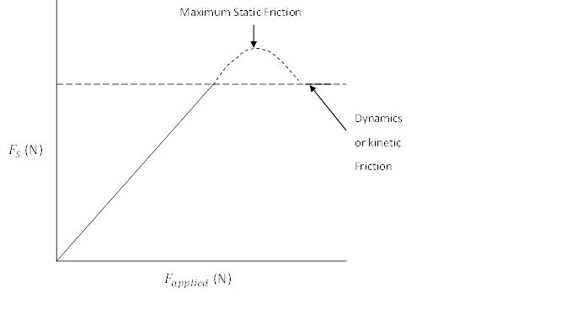

**Figure 2:** A plot of normal for FN against frictional force Fs

The implication of equation (1) is that Fs is equal to the applied force (Fapplied) as long as there is no movement of the object. Fig. 2 is an illustration of the relationship between the applied force and static friction Fs. The relation is broken just as the object is about to move. At this point, we have what is called maximum static friction

Fs,max = (2a)

where is called coefficient of static friction and FN = mg is the normal reaction or weight of the object.

The moment the object starts to move, dynamic friction or kinetic friction is called into play.

Dynamic friction

FK = (2b)

where is the coefficient of dynamic friction.

Static frictional force acts between surfaces at rest when a force is applied to make them slide over each other. Kinetic frictional force act between surface as they slide over each other.

Factors upon which friction depends are:

1. The nature of the two surfaces in contact
2. In the case of an object placed on a surface, friction depends on the weight of the object.

**Note:** Friction does not depend on the amount of surface area in contact or the relative speed of the bodies.

**3.1.1 Inclined Plane**

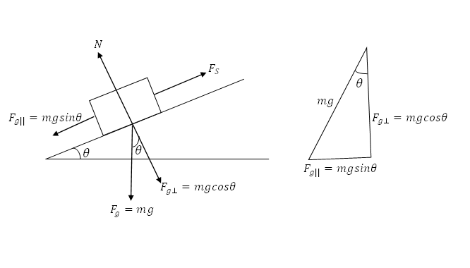

**Figure 3:** Object slinding on an inclined plane

Inclined plane can as well be treated like horizontal surface in which forces act along the surface. Figure 3 shows an object placed on an inclined plane and the forces. In this case, not only forces parallel to the surface and their directions are to be considered.

To be considered are the forces acting along the surface of the inclined plane, parallel component of the weight of the object and the friction (N = Normal Reaction). The right angle triangle on the right of Fig. 3 shows the weight and the parallel () and vertical () components of the weight.

If no external force acts on the object, the object will start to slide when is equal to the maximum static friction (i.e. ). At that point, one can estimate the coefficient of static friction of the inclined plane.

(3)

But and (i.e. from 3rd law)

(4)

(5)

**3.2 Work and Energy**

Work is done when an object is moved through a distance in the direction of the applied force, while energy is the ability to do work. The unit of work and that of energy is in Joule (J).

**3.2.1 Work Done By a Constant Force**

Suppose an object moves from an initial point to a final point so that the displacement of the point the force acts on is positive i.e.

Then, workdone

(6)

Work is a scalar quantity and the unit is in (J).

Work done against friction is given as

(7)

**3.2.2 Work Done By a Constant Force Applied at an Angle**

If the direction of the applied force is at an angle to the horizontal, then the *x*-component of the applied force is responsible for the motion of the object along the horizontal.

**Figure 4:** Three components of applied forces

Work done

**Conservation of Energy:** The law of conservation of energy states that the total energy of a closed system is constant.

**3.3 Work and Kinetic Energy**

From the definition of work, applied force must have moved an object through a distance – meaning that it causes the object’s speed to change. Hence, the work done on an object can be expressed as a function of the object’s final speed *v* and mass *m* i.e. kinetic energy (K.E) of the object.

(8)

**3.3.1 Work-Energy Theorem**

Consider the diagram in Fig. 5, assuming a net force in the direction indicated causes an object of mass *m* to move through a distance *s*. Then from the Newton’s 2nd law of motion,

*m*

*m*

FNet

*u*

*v*

*s*

**Figure 5:** Displacement of an object along a plane

= (9)

For a motion under constant acceleration, we write

(10a)

(10b)

where is the acceleration and *x* (or *s*) is the distance or displacement.

From the depth of work,

Inserting equation (1b), we have

(11)

We can therefore say that total net work done is equal to the change in kinetic energy.

**3.4 Collision**

Collision is an isolated event in which two or more bodies exert relatively strong forces on each other for a relatively short time.

**3.4.1 Impulse and Linear Momentum**

**Figure 6:** Two objects in collision

The diagram in Fig. 6 shows the collision between two objects A and B of different masses. If the collision is head-on, the direction of their final velocity will be along *x*-axis. The two forces and will change the linear momentum of both bodies. The amount of change *dp* according to Newton’s second law of motion is

(12)

Integrating over the interval – from initial time to final time

(13a)

The change in linear momentum of the body,

(13a)

i.e. the impulse (14)

For each body, change in the **linear momentum** is equal to the **impulse** that acts on the body.

**3.4.2 Momentum and Kinetic Energy In Collisions**

**Elastic Collision**: Both momentum and kinetic energy are conserved i.e. change in momentum *dp* = constant and .

**Inelastic Collision**: Momentum is conserved but kinetic energy decreases.

i.e. *dp* = constant but .

**3.4.3 Law of Conservation of Linear Momentum**

In a closed, isolated system containing a collision, the linear momentum of each colliding body may change but the total linear momentum of the system cannot change, whether the collision is elastic or inelastic.

**Collision in one dimension**: For objects moving along *x*-axis or *y*-axis, velocity has a single component. Under **in-elastic collision**, the two bodies join together after collision and move with common velocity *v*. Therefore, we can write;

Under an elastic collision in one dimension: The two bodies of masses and moving with initial velocities respectively, if after collision the velocities change to respectively, then we can write

(15a)

(15b)

(16a)

(16b)

**4.0 Summary**

In this unit you learnt

* that friction exists when there is a surface contacts between two bodies;
* that the total work done is equal to the total kinetic energy:
* the concept of collision between bodies and the change in the linear momentum
* how to solve physical problem relating to friction, work and energy.

**5.0 Self-Assessments Questions**

1. Define the following terms and give their respective units: (i) Friction (ii) Momentum (iv) Work (iv) Energy

2. What are the factors that frictional force depends on?

3. Differentiate between eleastic and inelastic collision.

4. In an experiment using a linear air track a, 0.5Kg rider travelling to the right at 2ms-1 collides with a stationary rider of mass 1Kg. Find the velocities of the two riders after the collision if:

* 1. It is perfectly elastic
  2. It is totally inelastic.

**6.0 Tutor Marked Assignments**

1.A 1600Kg van moving at 20ms-1 crashes into the back of a small car of mass 700Kg traveling in the same direction at 15ms-1.

1. What is the velocity of the two vehicles immediately after the collision of the lock together?
2. How much kinetic energy is transferred to other forms in the collision?

**7.0 References**

Adams, Steve & Allday, Jonathan (2000). Advanced Physics. UK: Oxford University Press.

Giancoli, D. C. (2008). *Physics for scientists & engineers with modern physics* (Vol. 2). Pearson Education.

Goel , V. K. (2007). Fundamentals of Physics Xi, Tata McGraw-Hill Education

Halliday, D., Resnick, R., & Walker, J. (2013). *Fundamentals of physics*. John Wiley & Sons.

Keith, Gibbs (2011). Advanced Physics (Second Edition). Cambridge University Press.

Michael Browne (2013). Schaum's Outline of Physics for Engineering and Science: 788 Solved Problems + 25 Videos, McGraw-Hill Professional

Nelkon, M & Parker, P (1995) Advanced Level Physics. New Delhi, India: CBS Publishers & Distributors.

Roger Muncaster (1993). A-level Physics, Nelson Thornes

Serway, R. A., & Vuille, C. (2014). *College physics*. Cengage Learning.

Young, H. D., Freedman, R. A., Sandin, T. R., & Ford, A. L. (1996). *University physics* (Vol. 9). Reading, MA: Addison-Wesley.

**8.0 Further Reading**

**Module 4: Elasticity and Oscillation**

**Unit 1: Intermolecular Force and Elasticity**

1.0 Introduction

2.0 Learning Outcomes

3.0 Main Content

3.1 Intermolecular Forces

3.2 Elasticity

3.3 Mechanical Properties of Materials

3.4 Young Modulus (E)

3.4.1 Stress

3.4.2 Strain

3.5 Elastic Energy Stored in a Stretched Wire

3.6. Modulus of Rigidity (G)

3.7 Bulk Modulus (B)

4.0 Summary

5.0 Self-Assessment

6.0 Tutor Marked Assignment

7.0 References

8.0 Further Reading

**1.0 Introduction**

This unit focuses on the effect of force on an elastic material which causes the length of the object to change. This change can be quantified by considering the mechanical properties (strength, stiffness, ductility and toughness) of the material. We shall also discuss the Hooke’s Law for an elastic material under the influence of an external force

**2.0 Learning Outcomes**

When you have studied this unit, you should be able to:

* explain the Intermolecular force
* apply Hooke’s law in solving physical problems
* explain the types of modulus of a material

**3.0 Main Content**

**3.1 Intermolecular Forces**

The elastic and thermal properties of a material especially in solid are the consequences of the molecular forces exerted on each other by solid which gave explanations on the mentioned properties.

The force at any point is found from the relation;

(1)

where V is the potential energy. Let consider the potential energy of two (2) molecules and the force between them that changes with their separation. The two forces act between the molecules. The graph given in Fig. 1 shows that the closer the molecules to each other the prominent is the repulsive force while attractive force between them is larger at greater distances. The resultant force is:

(a) repulsive from O to M

(b) attractive from M to B but increasing with distance.

(c) attractive from B to infinity but decreasing with distance.

The position M is where the two forces balance and this is the equilibrium points for molecules in the solid. At this point the potential energy is minimum. Any deviation from this equilibrium position would provide a force leading to retain the molecules to M.

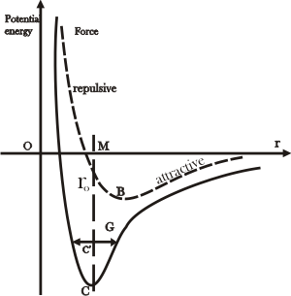

**Figure 1:** Intermolecular force graph

The attractive force increases as the molecules are separated from M to B. At point beyond point B (known as the breaking point), the force of attraction decreases with increasing separation between the molecules.

For a molecule to be completely separated from its neighbour it must acquire an amount of energy E represented by CM on the graph.

The latent heat of vaporization for the two molecules is CM when there is no residual attractive force, the CM also represents the latent heat of vaporization for the whole material. There is a linear relation of the forces and distances between the molecules at approximate distance OM (which is 2 to 3 10-10 m).

The explanation of the expansion of a solid with increasing temperature can be depict from the curve. If a molecule acquires an amount of energy E at C, its potential energy (P.E.) will rise to the level C’ and the energy appears as P.E and kinetic energy (K.E) which causes the molecule to oscillate about G.

However, since the P.E- distance curve is not symmetrical, the centre of oscillation is further from O than from M that implies the mean separation of the molecules known as expansion.

**3.2 Elasticity**

**Elasticity** is a property of all materials. A given material is said to be elastic if after being extended or stretched by the application of a force, it later returns to its initial position / size when the force or load is remove. The knowledge of elastic of nature of materials is of great importance in engineering and construction industries.

**Robert Hooke** proposed the Hooke’s law in 1676; he stated that extension of an elastic body is directly proportional to the force that produces it. Provided that the elastic limit is not exceeded, and the extension is small

Therefore,

(2)

and

(3)

where *F* = applied force

*k* = constant of proportionality known as spring constant

*e* = extension caused by applied force which is the define as the change in the length ( ) of the elastic material that is, the difference in the length of the material from final length ( to the original length (

A graph of force *F* against extension *e* given in Fig. 2 reveals that, the elastic region of OA shows that there is a linear proportional relationship between the extension (*e*) and the applied force (*F*). At this stage, the material of wire returns to its original size when the applied force is removed.

**A**

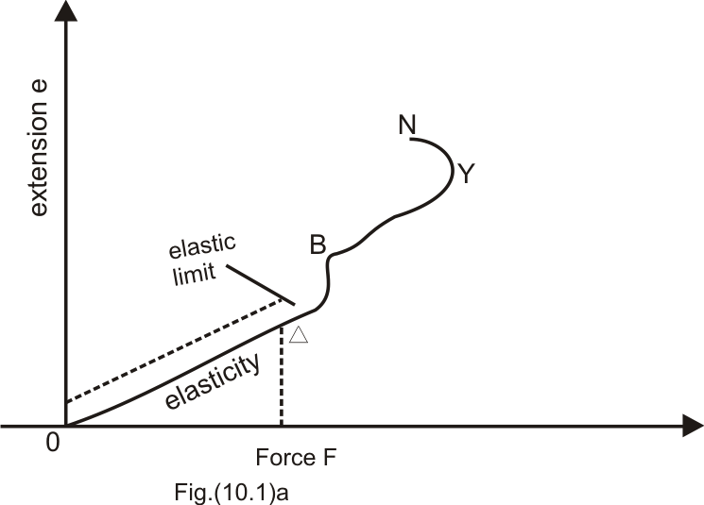

**Figure 2.** Graph of force (*F*) against extension (*e*) of an elastic material

Force (*F*) at point B is called the elastic limit, along OB the substance (wire) is said to be undergoing a change known as **elastic deformation**. The force at B is called the elastic limit that is limit of elasticity. When the elastic limit is exceeded, the wire will no longer be elastic and develop a permanent extension OB, when the force is removed at B. This point is known as the yield point. A further increase in the applied force results in a rapid increase extension along the path ABY and at point N, the wire breaks.

**3.3 Mechanical Properties of Materials**

The mechanical properties of a material are concerned with its behavior when subjected to the action of the external forces. Four important mechanical properties of material are its **strength**, **stiffness**, **ductility** and **toughness**.

1. **Strength:** is how the material deals/withstand the effect of applied force before breaking.
2. **Stiffness**: the opposition the material sets up to being distorted by having its shape or size or both changed. A stiff material is not flexible.
3. **Ductility** (workability): this is the ability of the material to be pressed, bend, rolled, cut or stretched into useful shapes.
4. **Tough** materials are those not brittle i.e. does not crack easily and readily.

**3.4 Young Modulus (E)**

This is defined as the ratio of **tensile stress** to the **tensile strain**.

Mathematically, we have

Young module, E = (4)

We can understand Young module, E better by explaining the terms **tensile stress** and **tensile strain**

**3.4.1 Stress**

This is produced in a material e.g. a wire when an applied force *F* is applied to one end of the wire of cross sectional area, *A* and original length, as illustrated in Fig (3).

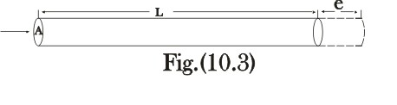

**Figure 3.** An illustration of a force applied to an elastic material which prodices an extension

Let a force **F** produce an extension *e*, the **stress** is thus defined as force per unit area. Mathematically, we have

(5)

The S.I unit of stress is Newton per square meter ( N/m2).

**3.4.2 Strain**

This is the ratio of the extension per unit length.

(6)

The new length of the elastic material describe in Fig. (3) is

(7)

where,

= original length

*L* = new length after extension

*e* = extension

From equation (6), it can be seen that strain is a unitless quantity.

According to Hooke’s law, strain is proportional to stress. This implies that

where the constant of proportionality is known as **Young Modulus** or **Modulus of Elasticity.**

The **modulus** is a measure of how difficult it is to deform the material and the modulus is classified into three (3), one for each kind of strain.

1. Young Modulus (E)

2. Modulus of Rigidity or (Shear Modulus) (G)

3. Bulk Modulus (B)

**Table 1:** Types of modulus and their descriptions

|  |  |  |  |
| --- | --- | --- | --- |
| **S/No** | **MODULUS** | **NATURE OF STRESS** | **NATURE OF STRAIN** |
| 1 | Young Modulus (E) |  | Change of shape and size |
| 2 | Modulus of Rigidity or (Shear Modulus) (G) |  | Change of shape but not size |
| 3 | Bulk Modulus (B) | Change of Pressure | Change of size but not shape |

**Key Idea:**

Young Modulus refers to a stretching or Compression.

Shear Modulus refers to twisting.

Bulk Modulus refers to a change of volume with pressure.

We can see that Young modulus is used to characterize the stretch ability of a material when it is subjected to a tensile stress.

From Table 1, we can rewrite the expression of Young module, E using equations (4) to (6) and we have

Longitudinal (or tensile) stress =

Longitudinal (or tensile) strain =

Young module, E = = (8)

The unit of Young module is determined by analysing the dimension of equation (9), we get

Young module, E =

**Example 1**

Calculate the extension (*e*) and evaluate the new length of a steel wire of 10 m long with cross sectional area of 0.01 cm2 hung from a support and a mass of 5 kg is hung from its end. Given the Young modulus for steel to be 210 GPa. (g = 10 ms-2)

**Solution**

*Given:*

Young modulus, E = 210 GPa =

The original length of the steel wire = 10 m

Hanged mass, *m* = 5 kg

Cross-sectional area, *A*= 0.01 cm2 = 0.01 10-4 m2 = 10-4 m2

Applied force F = mg = ms-2 = 50 kg ms-2 = 50 N

Note from the question that acceleration due to gravity, g = 10 ms-2.

Using equation (8), we can find the extension *e,* using by subject of the formula

New length can be calculated using equation (7),

L = 10.00238 m.

**3.5 Elastic energy stored in a stretched wire:**

Considered an unstretch wire of length *L*, let a force *F* produce an extension e, (assuming an elastic limit of the wire has not been exceeded and that no energy is lost as heat).   
The work done by *F* is equal to the energy gained by the wire.

work done = average force extension

Work done = *Fe* (9)

From Young modulus formula, we now have;

Work done = energy stored = Fe = (10)

From Fig. 2, the stretched material stored energy when force is applied to it and quickly returned to its original length (size) when the force is removed (provided the elastic limit of the material is not exceeded). But if it is exceeded and the applied force removed, the extension is partially recoverable and the energy is lost due to heat. This phenomenon of loss of energy is known as **hysteresis**.

**3.6. Modulus of Rigidity (G)**

The modulus of rigidity is also called *shear* which involves a change in shape but without change in volume.

Consider a tangential force *F* applied along the top surface of a cube with surface area is *A*. As a result of the applied force *F*, the cube suffers a change of shape and defined in way that the top and the below faces become rhombuses.

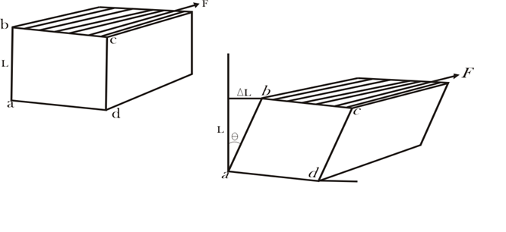

**(a)**

**(b)**

**Figure 5.** Illustration of a cube (a) before the application of a force (b) after the application of a force

The **sheer stress** is defined asthe ratio of the displacement ΔL of the corner of the material (cube) to the transverse dimension L

Shear strain = (11a)

Shear stress = (11b)

Modulus of rigidity (G) = (12a)

Putting equation (11a) and (11b) into (12), we have

Modulus of rigidity (G) = = (12b)

But from Fig.5b, shear strain can also be defined as

= tan θ (13)

Therefore, equation (12b) becomes

G = = (14)

**Example 2**

Given that the shear modulus for a certain metal is 50,000 Pa. Suppose that the shear force of 200 N is applied to the upper surface of a cube of this metal that is 3.0 cm on each side. How far will the top surface be displaced?.

**Solution**

*Given*

G = 50,000 Pa = 5 Nm-2,

F = 200 N,

L = 3.0 cm = 3.0 10-2 m,

ΔL = ?

Using equations (11a) and (11b), we have

shear stress = == 2.22 105 Nm-2

shear strain = =

From equation (12b),

**3.7 Bulk Modulus (B**)

**Bulk Modulus, B** involves the change of volume without change in shape. It is due to increase in external pressure which changes its volume by .

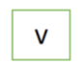

**(a)**

**(b)**

**Figure 6.** (a) Original volume of the body (b) After the body has been subjected to increase in external pressure ( and volume decreases to . Change in volume ,

Bulk stress (15)

Bulk strain (16)

(17)

-ve sign is introduced to address the in volume which is a decrease and hence –ve sign is introduced to make B (Bulk Modulus) positive (+ve), because is always a negative value.

**Example 3**

Determine the change in volume of copper cube with side dimension 40 mm each, when subjected to a pressure of 20,000 Pa. The Bulk Modulus of copper is 125 X 106 Pa.

**Solution**

= 20,000 Pa, B = 125 X 106 Pa, L = 40 mm = 40 X 10-3 m. V = L3 = (40 X 10-3)3 = 6.40 X 10-5 m3.

⇒

**Example 4**

Evaluate the fractional change in volume as the pressure of the atmosphere ( around a metal block is reduced to zero by placing the block in a vacuum. Given the Bulk Modulus for the metal to be 125 X 106 Pa.

**Solution**

**4.0 Summary**

In this unit you have learnt:

* the Intermolecular force
* the application of Hooke’s law, in solving physical problems the various types of modulus of a material such as young modulus (E), modulus of rigidity (G) and bulk modulus (B)

**5.0 Self-Assessment**

1. Explain what you understand by the following terms:

(i). Elastic limit (ii). Yield point (iii).Modulus of Elasticity.

2. A copper wire of length 150 m and diameter 0.002 m is extended by 0.02m when a load of W is attached to one of its ends. Calculate the value of this attached load W and Energy per unit volume.

3. The Shear Modulus of a metal cube is 5000 kPa. Suppose that the shear force of 200 N is applied to the top surface of the metal cube of sides 3.0cm each. How far will the top surface of the metal cube be displaced?.

4. Determine the volume change of a solid copper cube, with side dimension of 40.0 mm on each edge. When subjected to a pressure of 20 X 103 Pa. The bulk modulus for copper is 125 x 106 Pa.

**6.0 Tutor Marked Assignment**

1. Complete the young module (E) for an iron rod 4m long and 0.5 cm2 cross- sectional area extended by1 mm when a man of 225 kg is long from its lower end. (g = 9.8 m/s2).

2. A coil spring is used to support a 1.8 kg man. if the spring stretched 2 cm, what is the spring constant (k)? and what mass will be required to extend the spring by 5 cm? (g= 9.8 m/s2).

3. A wire whose cross sectional area is 4mm2 is extended by 0.1 mm by a certain weight. How far will the wire of the same material and length extends if its cross sectional area is 8mm2and the same weight is attached?

4. A uniform wire of unstretched length 2.49 m is attached to two points A and B which are 2.0 m apart and in the same horizontal line. When a 5 kg mass is attached to the midpoint C of the wire, the equilibrium position of C is 0.75 m below the line AB. neglecting the weight of the wire and taking the Young modulus for its material to be 2 X 1011 N/m2.

Find (i) the strain in the wire

(ii) the stress in the wire

(iii) the energy stored in the wire

**7.0 References**

Adams, Steve & Allday, Jonathan (2000). Advanced Physics. UK: Oxford University Press.

Giancoli, D. C. (2008). *Physics for scientists & engineers with modern physics* (Vol. 2). Pearson Education.

Goel , V. K. (2007). Fundamentals of Physics Xi, Tata McGraw-Hill Education

Halliday, D., Resnick, R., & Walker, J. (2013). *Fundamentals of physics*. John Wiley & Sons.

Keith, Gibbs (2011). Advanced Physics (Second Edition). Cambridge University Press.

Michael Browne (2013). Schaum's Outline of Physics for Engineering and Science: 788 Solved Problems + 25 Videos, McGraw-Hill Professional

Nelkon, M & Parker, P (1995) Advanced Level Physics. New Delhi, India: CBS Publishers & Distributors.

Roger Muncaster (1993). A-level Physics, Nelson Thornes

Serway, R. A., & Vuille, C. (2014). *College physics*. Cengage Learning.

Young, H. D., Freedman, R. A., Sandin, T. R., & Ford, A. L. (1996). *University physics* (Vol. 9). Reading, MA: Addison-Wesley.

**8.0 Further Reading**

**Unit 2:** Simple Harmonic Motion

1.0 Introduction

2.0 Learning Outcomes

3.0 Main Content

3.1 Periodic Motion

#### 3.2 A Hookean System

3.4 The Simple Pendulum

3.3 The Elastic Potential Energy

4.0 Summary

5.0 Self-Assessment

6.0 Tutor Marked Assignment

7.0 References

8.0 Further Reading

**1.0 Introduction**

This unit focuses on the basic type of vibration or oscillation of an object called simple harmonic motion (SHM). Many objects vibrate or oscillate for example, an object attached to the end of a spiral spring, a tuning fork, the balance wheel of an old watch, a pendulum, the strings of a guitar or piano etc. produce different forms of vibration that creates a back and forth or up and down.

**2.0 Learning Outcomes**

When you have studied this unit, you should be able to:

1. explain simple harmonic (SHM)
2. describe simple pendulum.
3. solve simple harmonic problem

**3.0 Main Content**

**3.1 Periodic Motion**

There are two basic ways to measure time: by *duration or periodic motion*. Early clocks measured duration by calibrating the burning of incense or wax, or the flow of water or sand from a container. Our calendar consists of years determined by the motion of the sun; months determined by the motion of the moon; days by the rotation of the earth; hours by the motion of cyclic motion of gear trains; and seconds by the oscillations of springs or pendulums. In modern times a second is defined by a specific number of vibrations of radiation, corresponding to the transition between the two hyperfine levels of the ground state of the cesium 133 atom.

One of the most important examples of periodic motion is simple harmonic motion (SHM), in which some physical quantity varies sinusoidally. Suppose a function of time has the form of a sine wave function,

(1)

where *A* > 0 is the amplitude (maximum value). The function *y*(*t*) varies between *A* and −*A*, because a sine function varies between +1 and -1. A plot of *y*(*t*) vs. time is shown in the Fig.1.

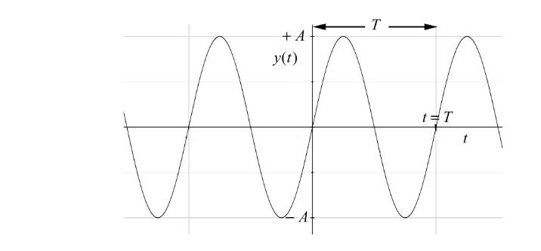

**Figure 1.** The graph of time (*t*) against the function *y*(*t*)

The sine function is periodic in time. This means that the value of the function at time, *t* will be exactly the same at a later time , where *T* is the **period**.

The **frequency**, *f*, is defined to be

(2)

The SI unit of frequency is inverse seconds, [s1‑]or hertz [Hz].

**Example 1**

A spring makes 12 vibrations in 40 s. Find the period and frequency of the vibration.

**Solution**

Period = T

Also,

Frequency = f

The **angular frequency** of oscillation is defined to be

(3)

and is measured in radians per second (rad/s). The angular frequency of oscillation is denoted by ω0 to distinguish from the angular speed ω = dθ/dt. One oscillation per second, 1Hz, corresponds to an angular frequency of 2π rads-1. Unfortunately, the same symbol ω is used for angular speed in circular motion. For uniform circular motion, the angular speed is equal to the angular frequency but for non-uniform motion the angular speed is not constant. The angular frequency for simple harmonic motion is a constant by definition. We therefore have several different mathematical representations for sinusoidal motion

(4)

**The Amplitude**is the maximum displacement of the vibrating body from its equilibrium position (rest position). It is measured in meters.

**A restoring force**is one that opposes the displacement of the system; it is necessary if vibration is to occur. A restoring force is always directed so as to push or pull the system back to its equilibrium position.

**NOTE:**A central feature of SHM is that the system oscillates at a single constant frequency.

#### **3.2 A Hookean System**

#### Ahookean systemfor a spring, wire, rod, etc. is a system that returns to its original form after being distorted and then released. Moreover, when such a system is stretched a distance *x*, though for compression, *x* is negative**,** the restoring force exerted by the spring is given by Hooke’s Law

#### (5a)

#### where the negative sign connotes the restoring force is always opposite in direction to the displacement), k is the spring constant in N/m. It measures the stiffness of the spring.

Expressing Hooke’s law in terms of the external force needed to stretch the spring a given amount *x*, this force is the negative of the restoring force, hence

(5b)

**3.3 The Elastic Potential Energy**

The energy (PE) stored in a hookean spring that is distorted a distance *x* is given as

PE = (6)

This energy is completely stored in the spring only when the mass has its maximum displacement.

There is an interchange of energy between kinetic and potential energy that occurs constantly in a vibrating system.

* When the system passes through its equilibrium position, KE = maximum and PE = 0.
* When the system has its maximum displacement, then KE = 0 and PE = maximum.

According to the law of conservation of energy, in the absence of friction-type losses,

KE + PE = Constant.

For a mass *m* at the end of a spring with a negligible mass, we have

(7)

where x0 is the amplitude of the motion.

The **speed** in SHM is determined through the above equation of energy as

(8)

(9a)

(9b)

From equation (8) and (9b), we have

(10)

**Acceleration** in simple harmonic motion can be determined via Hooke’s law, F = - k*x*, and

F = ma; equating the two equations gives

(11)

The negative sign in equation (10) indicates that the direction of *a* is always opposite to the direction of the displacement *x*.

Let’s consider a reference circle giving in Fig.2, which as a point *P* moving with constant velocity around the circle. The point A coincides with horizontal diameter of the circle. The motion of the point A back and forth about point O as a center is SHM. The amplitude of the motion is , the radius of the of the circle. The time taken for the point P to go around the circle once is the period T of the motion. The velocity, of point A has a scalar x-component of

(12)

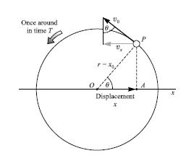

**Figure 2**. Reference circle for illustrating a simple harmonic motion (SHM)

**Period** in SHM is represented with *T* and it is the time taken to make one complete cycle/oscillation. Considering the sketch given in Fig.2, therefore,

T = (13)

But is the maximum speed of point *A* in Fig.2, this implies in SHM when the amplitude *x* = 0, that is equation (8) and (10) gives

= (14)

Equation (14) is used for calculating the maximum velocity, when the amplitude *x* = 0.

For a Hookean spring system is expressed as

(15)

**Example 2**

If the period of a simple harmonic motion is 8 s, and the particle oscillates through a distance of 1.2 m on each side of the central position, find the maximum velocity, and also the velocity when the particle is 0.6 m from the central position.

**Solution**

Given T = 8 s, =1.2 m

From equation (3), we have

From equation (14), the maximum velocity is when *x* = 0, and then

When *x* = 0.6 m,

We use equation (10),

**Example 3**

Two identical springs have k = 20 N/m. A 0.30 kg mass is connected to them as shown in the figures a & b below. Find the period of motion for each system. Ignore friction forces.

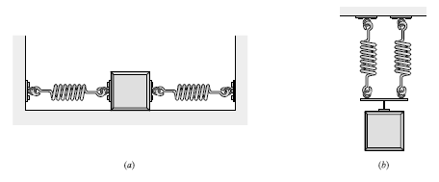

**Solution**

(a) When the spring is given a displacement x > 0, one spring will be stretched x and the other will be compressed x. They will each exert a force of magnitude (20 N/m)x on the mass in the direction opposite to the displacement. Hence the total restoring force will be F = -(20)x - (20)x = -(40 N/m)x.

Comparing with F = -kx, then k = 40 N/m. Hence,

= = 0.54 s

(b) When the mass is displaced a distance y downward, each spring is stretched a distance y. The net restoring force on the mass is then

F = - (20)y - (20)y = - (40N/m)y. With the solution in (a), T is also 0.54 s.

**3.4 The Simple Pendulum**

The simple pendulum very nearly undergoes SHM if its angle of swing is not too large. The period of vibration for a pendulum of length L at a location where the gravitational acceleration is g is given by

(16)

Simple Harmonic Motion can be expressed in an analytical form with reference to Fig.2 above where we see that the horizontal displacement of point *P* is given by *x* = *x*0cosθ. Since θ = = 2πft, where the angular frequency = 2πf is the angular velocity of the reference point on the circle, we have

(17)

Also, the vertical component of the motion of point *P* is given as

(18)

**4.0 Summary**

In this unit you have learnt:

1. simple harmonic motion (SHM) which describes the vibration of an object oscillating back and forth
2. the description simple pendulum and can apply the equation
3. how to solve problem involving simple harmonic problem

**5.0 Self-Assessments**

1. Compute the acceleration due to gravity at a place where a simple pendulum 150.3 cm long makes 100.0 cycles in 246.7 s. ANS. 9.749 ms-2
2. A 300 g mass at the end of a spring oscillates with amplitude of 7.0 cm and a frequency of 1.80 Hz. (a) Find its maximum speed and maximum acceleration (b) what is its speed when it is 3.0 cm from its equilibrium position? ANS. (a) 0.79 m/s, 8.9 m/s2 (b) 0.72 m/s

**6.0 Tutor Marked Assignment**

1. With a 50 g mass at its end, a spring undergoes SHM with a frequency of 0.70 Hz. How much work is done in stretching the spring 15 cm from its unstretched length? How much energy is then stored in the spring? ANS. 0.011 J, 0.011 J
2. A 500 g mass is attached to the end of an initially unstretched vertical spring for which the stiffness is 30 N/m. The mass is then released, so that it falls and stretches the spring. How far will it fall before stopping? (*Hint:* the PEG lost by the mass must appear as PEe) ANS. 33 cm

**7.0 References**

Adams, Steve & Allday, Jonathan (2000). Advanced Physics. UK: Oxford University Press.

Giancoli, D. C. (2008). *Physics for scientists & engineers with modern physics* (Vol. 2). Pearson Education.

Goel , V. K. (2007). Fundamentals of Physics Xi, Tata McGraw-Hill Education

Halliday, D., Resnick, R., & Walker, J. (2013). *Fundamentals of physics*. John Wiley & Sons.

Keith, Gibbs (2011). Advanced Physics (Second Edition). Cambridge University Press.

Michael Browne (2013). Schaum's Outline of Physics for Engineering and Science: 788 Solved Problems + 25 Videos, McGraw-Hill Professional

Nelkon, M & Parker, P (1995) Advanced Level Physics. New Delhi, India: CBS Publishers & Distributors.

Roger Muncaster (1993). A-level Physics, Nelson Thornes

Serway, R. A., & Vuille, C. (2014). *College physics*. Cengage Learning.

Young, H. D., Freedman, R. A., Sandin, T. R., & Ford, A. L. (1996). *University physics* (Vol. 9). Reading, MA: Addison-Wesley.

**8.0 Further Reading**

**Module 5: System of Particles**

**Unit 1: Center of Mass**

1.0 Introduction

2.0 Learning Outcomes

3.0 Main Content

3.1 Definition

3.2 Velocity and Acceleration of CM

3.3 Continuous Mass Distribution

4.0 Summary

5.0 Self-Assessment Questions

6.0 Tutor Marked Assignments

7.0 References

8.0 Further Reading

**1.0 Introduction**

This unit focuses on center of mass concept which is central to the study of the motion of many-particle systems. Here we shall not be concerned with the study of the motion of such systems but with their mass distribution. Recall that particles are bodies with negligible spatial extent and internal structure. Real objects on the other hand are many-body system consisting of very large number of particles. At the extreme, these objects may either be a rigid body or a fluid.

**2.0 Learning Outcomes**

By the end of this lesson, you should be able to:

* explain the concept of center mass
* describe the center mass of a continuous distribution of mass
* solve center mass problems

**3.0 Main Content**

**3.1 Definition**

The center of mass of a many-body system is defined as the point in the system which moves as if the total mass is concentrated at that point. For an isolated n-body system with no external force, the total momentum P~ is given by

(1)

(2)

(3)

where *r*i (i = 1, 2, . . . , *n*) are the position vectors of each particle in the system. Note that the masses

are time independent ( The centre of mass of the system is then defined by the position vector

(4)

(5)

(6)

Where *M* = is the total mass of the system. The corresponding cartesian coordinate of

the position vector is given by

(7)

(8)

(9)

**3.2 Velocity and Acceleration of CM**

Since the velocity V is defined as the rate of change of displacement with time then

(10)

(11)

The acceleration A is the rate of change of velocity with time

(12)

(13)

(14)

We see from the above that the CM moves like a single point mass i.e. it moves with constant velocity in the absence of the external force and accelerates when the resultant force is non-zero. The CM therefore exhibits a simple motion irrespective of the motion of the constituent bodies.

**Example 1**

Two masses are placed on a 1.5 m long massless rod. The masses are arranged such that a 1.6 kg mass is placed at the left end of the rod and a 1.8 kg mass is placed at 1.2 m from the left end.

a.) What is the location of the CM ?

b.) By moving the 1.8 kg mass, can you arrange to have the CM in the middle of the rod?

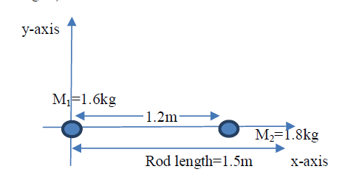

**Figure 1:** Location of center of mass between two masses M and M­2

**Solution**

a.) Arrange the masses on a 1-D coordinate such that the left most mass is placed at the origin

(see Fig. 1)

Using equation (7), we have

b.) Let the 1.8 kg mass be at *x*2 and the mid-point be *x*m = 0.75 m. If the CM is located at *x*m , then X = 0.75 m

**Example 2**

In the question above, determine the CM of the new system if a third mass of 2.3 kg is placed at a distance of 1.1 m vertically above the 1.6 kg such that a straight line connects the CM of the 1.6 kg and that of 2.3 kg.

**Solution**

This is now a 2-D configuration, and the *x*,*y* coordinate system will be considered

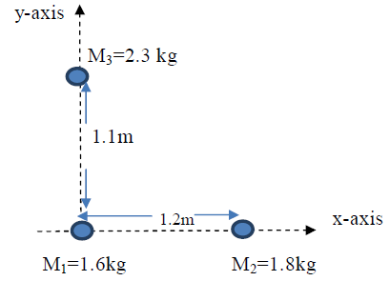

**Figure 2**

Using equations (7) and (8), we have

**3.3 Continuous Mass Distribution**

A solid object is a many-particle system consisting of tiny particles that are not visible to our naked eyes. Such systems are considered as continuous of matter. The CM of a continuous distribution of mass may be defined by considering a rod of length *L* (with ends a and b) divided into equal length Δ*X* but not necessarily of equal mass unless the mass distribution is uniform. If the *i*-th segment has a mass Δ*m*i , the local mass density is given by . The total mass of the rod M may then be expressed as

(15a)

(15b)

for infinitesimal (16)

The corresponding CM of the linear mass distribution may then be written as

(17)

(18)

(19)

where is the mass density.

**Example**

Consider a rod of length L, whose mass density is given by λ = C (1 + ax2 ), where x is the distancefrom the light end and C is a constant with a dimension of mass per unit length. Obtain the expression for CM of the rod.

**Solution**

Require to determine the CM *X* using the expression.

(20)

And using equation (16), we get

**4.0 Summary**

In this unit, you have learnt

* the description of center mass been described by the position vector
* that in order to estimate the center of mass of a solid, we need to describe the center mass of the continuous distribution of mass of the solid object
* solving physical problems that involves the calculation of center mass parameters.

**5.0 Self-Assessment Questions**

1. Define center of mass

2. What do you understand by center mass of the continuous distribution

3. Three masses are placed on the *x*-axis: 200 g at *x* = 0, 500 g at *x* = 30 cm, and 400 g at *x* = 70 cm. Find the center of mass.

**6.0 Tutor Marked Assignments**

1. Two masses m1 = 15 kg and m2 = 25 kg are joined by connecting a rod of length 0.8 m. Determine the

distance of the CM of the system from the m1 if (a) the connecting rod is massless, and (b) the connecting

rod is a uniform rod of mass 15 kg.

2. Find the location of the CM of a system of three particles arranged such that two of the particles with

mass m are separated by distance l along the *y*-axis. The third mass 2 m lies on the *x*-axis and is

separated by a distance l from one of the masses ( m = 12 kg and L = 1.5 m)

**HINTS**

1. You are asked to determine CM of the system from m1,

a. This is similar to what we have in Fig.1, which implies *that m1 = 15 kg, x1 = 0.0 m, m2 = 25 kg and x2 =0.8 m* (i.e. the length of the rod).

b. If the rod is a uniform rod of mass 15 kg , the CM of a uniform object( of

any shape) is at the center. Therefore, it will appear as if there is a third

mass on the system located at the middle i.e. 0.4 m from *m1 = 15 kg, x1 = 0.0 m, m2 = 25 kg and x2 =0.8 m, mrod = 15 kg, xrod = 0.4 m* then you can obtain CM (i.e. *x*) for this system.

2. Diagram

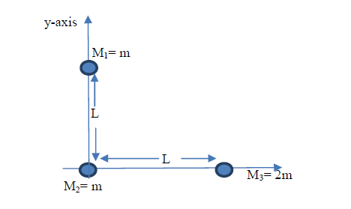

Taking m2 as the origin

m1 = m = 12 kg, *x*1 = 0 , y1 = 0

m2 = m = 12 kg, *x*2 = 0, y2 = l = 1.5 m

m3 = 2m = 24 kg, *x*3 = l = 1.5 m y3 = 0

Then follow the steps in example 2 to obtain and θ.

**7.0 References**

Adams, Steve & Allday, Jonathan (2000). Advanced Physics. UK: Oxford University Press.

Giancoli, D. C. (2008). *Physics for scientists & engineers with modern physics* (Vol. 2). Pearson Education.

Goel , V. K. (2007). Fundamentals of Physics Xi, Tata McGraw-Hill Education

Halliday, D., Resnick, R., & Walker, J. (2013). *Fundamentals of physics*. John Wiley & Sons.

Keith, Gibbs (2011). Advanced Physics (Second Edition). Cambridge University Press.

Michael Browne (2013). Schaum's Outline of Physics for Engineering and Science: 788 Solved Problems + 25 Videos, McGraw-Hill Professional

Nelkon, M & Parker, P (1995) Advanced Level Physics. New Delhi, India: CBS Publishers & Distributors.

Roger Muncaster (1993). A-level Physics, Nelson Thornes

Serway, R. A., & Vuille, C. (2014). *College physics*. Cengage Learning.

Young, H. D., Freedman, R. A., Sandin, T. R., & Ford, A. L. (1996). *University physics* (Vol. 9). Reading, MA: Addison-Wesley.

**8.0 Further Reading**

**Unit 2: Rigid Body Dynamics**

1.0 Introduction

2.0 Learning Objectives

3.0 Main Content

3.1 Rotation of a rigid body about a fixed axis

3.1.1 Angular Position, θ

3.1.2 Angular Displacement Δθ

3.1.3 Angular velocity

3.1.4 Angular Acceleration

3.2 Rotational Motion under Constant Angular Acceleration

3.3 Linear and Angular Variables

3.4 Kinetic Energy of Rotation

3.5 Moment of inertial *I*

3.5. 1 Determination of *I* for Various forms or Shapes of Bodies

3.6 Parallel Axes Theorem

3.7 Perpendicular Axes Theorem

3.8 Radius of Gyration

4.0 Summary

5.0 Self-Assessment Questions

6.0 Tutor-Marked Question

7.0 Reference

8.0 Further Links

**1.0 Introduction**

A rigid body is a body that can rotate with all its parts locked together and without any change in its shape.

**2.0 Learning Objectives**

By the end of this lesson, you should be able to:

* explain the concept of rigid body
* calculating moment of inertia for different shape of objects
* solving problems relating to rigid body system involving moment of inertia and radius of gyration

**3.0 Main Content**

**3. 1 Rotation of a rigid body about a fixed axis**

A fixed axis means that the rotation occurs about an axis that does not move.

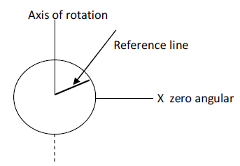

position

**Figure 1:** Rotation about a fixed axis

Consider a disk rotating about an axis shown in the diagram in Fig. 1above with reference line fixed on the desk and x is on the zero angular position.

We can define the following.

**3.1.1 Angular Position, θ**

This is the angle of the reference line relative to a fixed direction which is taken as the zero angular position in the diagram in Fig. 2.

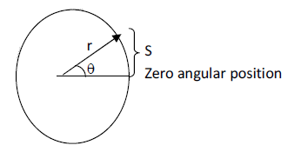

**Figure 2:** Reference line

From the diagram shown in Fig.2, we have

(1)

For small θ, sin θ ≅ θ

(2)

s = length of are along a circle.

r = radius of that circle.

θ is measured in radian or revolution, 1 revolution = 360° = 2π rad.

1 rad = 57.3° = 0.159 rev

**3.1.2 Angular Displacement Δθ**

If a body rotates about the rotation axis with the angular position of the reference line changing from θ1 to θ2, the resulting angular displacement Δθ is given by

Δθ = θ2 – θ1 (3)

Δθ is positive for counter clockwise direction and – ve for clockwise direction.

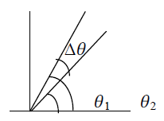

**Figure 3:** Change in the angular position about the rotation axis

**3.1.3 Angular velocity**

Consider a rotating body with angular position θ1 at time t1, and angular position θ2 at time t2.

Average velocity was is given by

(4)

Also, instantaneous angular velocity

(5)

is measured in radian per second (rad.s-1) or revolution per second (rev.s-1).

1 rev.s-1 = 2*π rad*. s-1. Angular velocity can also be measured in *rev*. /min, and

,

**3.1.4 Angular Acceleration**

A changing angular velocity means that an angular acceleration is occurring.

Average angular acceleration of a rotating body in the interval t1 and t2 is defined as

(6)

Instantaneous angular acceleration

(7)

is measured in rad s– 2 or rev. s-2

**Example 1**

After being turned on, a turntable reaches its rated angular speed of 45.0 rev/min in a time interval of 4.10 s what is the average angular acceleration in rad/s2?

**Solution**

From the question the turntable with initial angular speed of 0.0 rev /min started to rotate and

reached an angular speed of 45.0 rev/min in 4.10 s. This implies that

,

Therefore, using equation (6),

**3.2 Rotational Motion under Constant Angular Acceleration**

Under constant angular acceleration the following equations similar to linear motion under constant acceleration can be derived:

Using equation (6) and if *t*1 = 0, *t*2 = *t*, and

(Equivalent of ) (8)

Others are:

and if

(Equivalent of ) (9)

, and if

(Equivalent of ) (10)

(Equivalent of ) (11)

**3.3 Linear and Angular Variables**

If a reference line on a rigid body rotates through angle θ about an axis

(12)

Differentiating the equation above gives us the speed

(13)

But is the linear velocity and is the angular speed

(14)

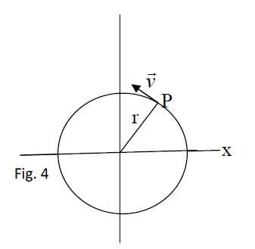

**Acceleration**

Differentiating (14) with respect to *t*

, which implies that

(15)

Also, radial acceleration

(i.e. the acceleration for circular motion) (16)

Put equation (14) in equation (16)

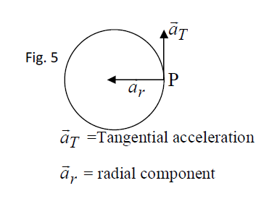

**3.4 Kinetic Energy of Rotation**

A rotating body possesses K.E, because its constituent points are in motion. If the point’s mass is *m* as shown in the diagram in Fig. 6, K.E of a single point can be written as

where v*T* is the tangential speed or linear speed as shown in Fig. 5 (i.e. *aT*)

(18)

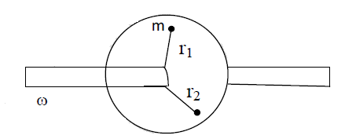

**Figure 6**

The K.E of the entire rotating body is the sum of K.Es of the points

Rotational K.E = (19)

and is called moment of inertial of the body. It is a constant for a particular rigid

body and a particular rotating axis.

Therefore rotational kinetic energy

K.E = (20)

where is in rads-1 and K.E in Joule (J).

For a rigid body undergoing both rotational and translated motion, the total K. E of the body is the sum of its translational and rotational kinetic energies.

Total K.E = (21)

**3.5 Moment of inertial *I***

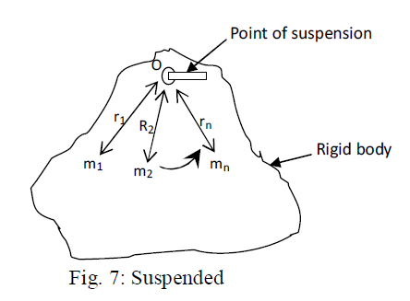

**Figure 7:** Suspended

Consider a rigid body rotating about O, containing particle masses and at distances from O, the sun of the products of mass of each particle of the body and the square of its perpendicular distance from the axis of rotation is called moment of inertia *I*.

(22)

Unit of *I* = kgm2

Total rotational kinetic energy (K.E) =

Moment of inertia is analogous to mass but the main differences are:

(a) Its value own varies for a body while mass is constant

(b) Its unit is kgm2 but kg is for mass.

(c) It depends on how mass is distributed in a body but mass is not

(d) It exists for a rotating rigid body but mass does not depend on rotation

**3.5.1 Determination of *I* for Various forms or Shapes of Bodies**

(a) Moment of Inertia I for a uniform rod rotating about an axis through its centre

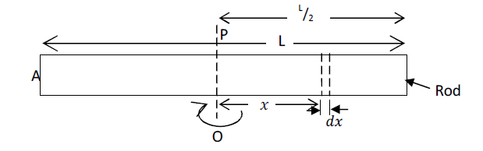

**Figure 8:** Rod, rotating about axis O at its centre

The rod of length L in this case can be assume to extend from to . Assuming an element *dx* at distance *x* from the axis of rotation O as shown in Fig. 8, we can estimate moment of inertial *I* for this element. And to obtain moment for the whole rod, we integrate over to whole length of the rod.

If the mass of rod is *m*, the length of the rod is *L*, the cross sectional area of the rod is *A*, and the density of the material from which the rod is made is ρ, then volume of the element *dx*, dV = A*dx* (i.e. where), and mass of the element

(23)

(i.e. from density = mass / volume ⟹ mass = density × volume)

Mass *m* of the whole rod of length L is given as

(24)

Therefore,

*I* for the element shown in Fig. 7 about OP = (i.e. from)

*I* for the whole rod = (25)

(26)

, but from equation (24),

Therefore

(27)

(b) *I* for a uniform rod rotating about an axis through one end

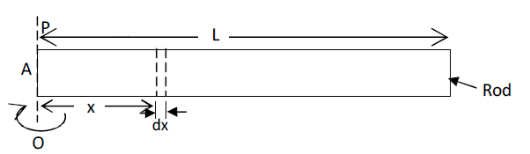

**Figure 9:** Rod, rotating about axis O at one end

If the axis of rotation of the rod shown in Fig. 8 is now at one end of the rod, using the same assumption as in Fig. 8, the moment of inertial of element *dx* is the same as equation (23).

Then, for the whole rod, we integrate from 0 to L. Therefore,

I for the whole rod (28)

(29)

Using the mass of the rod in equation (24),

(30)

(c) *I* of ring about axis through its centre

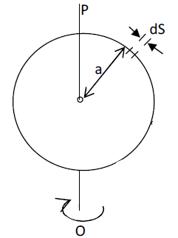

S

Circumference of

the circular track

**Figure 10:** Circular ring rotating about its axis

Mass of ring = *m*

Length of the ring *S* is 2π*a*, linear density of the ring is ρ (i.e. mass / length), length of the

element is *dS*, and mass of the element is ρ*dS*. This implies that mass of the whole ring will

be written as:

(31)

where *a* is the radius of the ring.

Moment of inertial of the element *dS* is

(32)

Moment of inertial for the whole length of the ring (i.e. from 0 to )

(33)

Using equation (31), it becomes

(34)

(d) I of a circular disc rotating about an axis through its centre

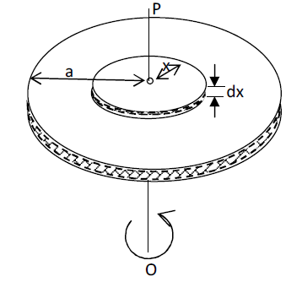

**Figure 11:** Circular disc rotating about its axis

Let (i.e. mass / area) and using for a circular disc,

⟹

Area of slice (i.e. the pipe form shown in Fig. 11) =

Mass of slice =

Moment of inertia of slice = (35)

For the whole disc (36)

Therefore, for a circular disc rotating about its centre

(37)

(e) *MI* of solid cylinder about axis through its centre

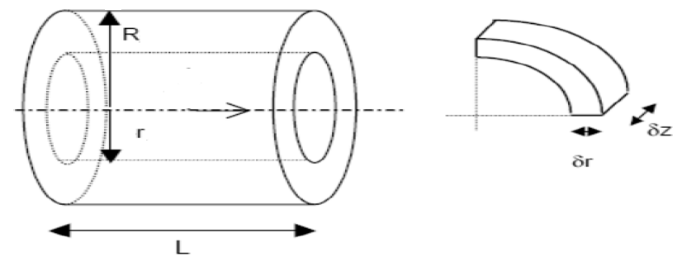

**Figure 12:** A solid cylinder rotating about its centre

Consider a solid cylinder shown in Fig. 12, an element () as indicated in the right side figure is distance *r* from the axis of rotation while the radius of the surface area of the cylinder is *R*.

Volume of the element i.e.

This is from and by differentiation

The mass of the element is therefore

(38)

*I* for the element of mass i.e.

We can then integrate about the whole radius of the cylinder to obtain the moment of inertial

*I*,

(39)

, but then

(40)

(f) *I* for a Hollow cylinder rotating about an axis through its centre

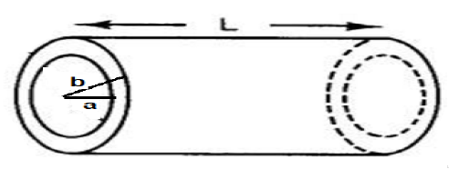

**Figure 13:** Hollow cylinder of inner radius *a* and outer radius *b*

A hollow cylinder rotating about its centre will have it moment of inertial similar to that of a

solid cylinder also rotating about its centre – the only difference is that the integration in equation (39) will be from inner radius *a* and outer radius *b*. So we have

(41)

But , and then,

(42)

**3.6 Parallel Axes Theorem**

The moment of inertia of a body about any axis is equal to the moment of inertia *I*G about a parallel axis through the centre of gravity of the body plus *Mh*2, where *M* is the mass of the body and *h* is the distance between the two axes.

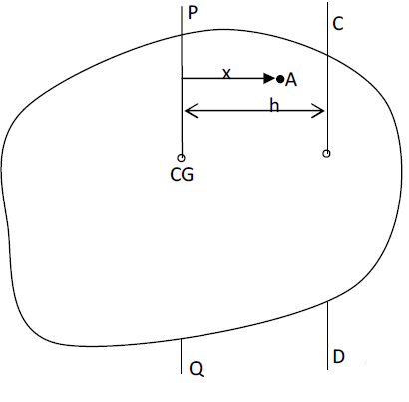

Let *I* = *MI* about CD

IG= *MI* about PQ, axis through point of the centre of gravity CG,

PQ is parallel to CD and h is perpendicular distance away from CD

Let a unit Particle A of mass m be at distance x from PQ axis.

Moment of inertia I of A about CD =

i.e.

(43)

But (M = total mass) (44)

(45)

(46)

since =Sum of moment about CG = 0,

Using equations (2), (3) and (4) in equation (1)

i.e. (Parallel axis law proved). (47)

**Example 2**

What is the moment of *I* of a disc, whose radius is ‘*a*’ and mass is *m*, about an axis PQ

through a point on its circumference perpendicular to its plane (Its IG = *M*a2/2)

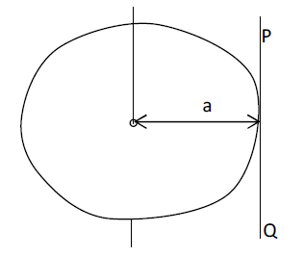

What is I of a solid cylinder about an axis along its height, if IG = Ma2/2?

**Solution**

(parallel axis theorem)

So

i.e.,

(48)

**3.7 Perpendicular Axes Theorem**

The moment of inertia *I* of a body about any axis is the sum of the moment if inertia about any mutually perpendicular axes. This theorem is most useful when considering a body which is of regular form (i.e. Symmetrical about two out of three axes). If the moment of inertia about these axes is then the third may be calculated.

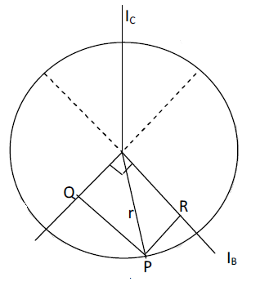

IA

A and B are mutually perpendicular and are through symmetry of the body.

From

But

i.e

(49)

i.e. (perpendicular axis theorem).

**Example 3**

Find the M I of disc about axis through its diameter

through its centre perpendicular to its plane

i.e. through its centre of mass.

i.e.

i.e. MI about A is of

And the rest half is *MI* about B.

Axes A and B are parallel to the plane of the disc.

Thus, MI through diameter = (50)

**3.8 Radius of Gyration**

If we write M of I as , *k* = distance called radius of gyration of the body. Thus, radius of gyration is the defined as the distance from the centre of rotation to the point where the mass can be considered to be concentrated.

**Example 4**

For disc , write expression for its radius of gyration as

i.e

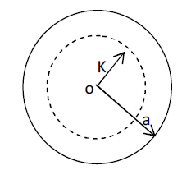

(2) Given that *I* of rod if its length is 1 m and mass is 50 g calculate its radius of gyration

**4.0 Summary**

In this unit, you have learnt

* the concept of rigid body
* how to calculate moment of inertia for different shape of objects such as uniform rod, ring, disc rotating and hollow cylinder
* application of useful equations for solving problems relating to rigid body system involving moment of inertia and radius of gyration.

**5.0 Self-Assessment Questions**

1. An automatic drier spins wet clothes at an angular speed of 65 rev/min. starting from rest

the drier reaches its operating speed with an average angular acceleration of 7.0 rads-2. How

long (in seconds) does it take the driver to come up to this speed?

2. The angular speed of an automobile engine is increased at a constant rate from 1200 rev/min to 3000 rev/min in 2s.

(a) What is its angular acceleration in revolutions per minute squared?

(b) How many revolutions does the engine make during this 12 seconds interval?

**6.0 Tutor-Marked Question**

1. During a time interval *t* the flywheel of a generator turns through the angle

, where *a*, *b* and *c* are constants. Write expressions for the wheel’s (a) angular velocity and (b) angular acceleration.

2. A diver makes 2.5 revolutions on the way from a 10 m high platform to the water. Assuming zero vertical velocity find the driver’s average angular velocity during a dive.

4. A record turntable rotating at 33⅟2 rev/min slows down and stops in 30 s after the motor is turned off.

(a) Find its (constant) angular acceleration in rev min-2

(b) How many revolutions does it make in this time?

5. A disk initially rotating at 120 rads-1 is slowed down with a constant angular acceleration of magnitude 4.0 rads-2,

(a) How much time does the disk take to stop?

(b)Through what angle does the disk rotate during that time?

**7.0 Reference**

Adams, Steve & Allday, Jonathan (2000). Advanced Physics. UK: Oxford University Press.

Giancoli, D. C. (2008). *Physics for scientists & engineers with modern physics* (Vol. 2). Pearson Education.

Goel , V. K. (2007). Fundamentals of Physics Xi, Tata McGraw-Hill Education

Halliday, D., Resnick, R., & Walker, J. (2013). *Fundamentals of physics*. John Wiley & Sons.

Keith, Gibbs (2011). Advanced Physics (Second Edition). Cambridge University Press.

Michael Browne (2013). Schaum's Outline of Physics for Engineering and Science: 788 Solved Problems + 25 Videos, McGraw-Hill Professional

Nelkon, M & Parker, P (1995) Advanced Level Physics. New Delhi, India: CBS Publishers & Distributors.

Roger Muncaster (1993). A-level Physics, Nelson Thornes

Serway, R. A., & Vuille, C. (2014). *College physics*. Cengage Learning.

Young, H. D., Freedman, R. A., Sandin, T. R., & Ford, A. L. (1996). *University physics* (Vol. 9). Reading, MA: Addison-Wesley.

**8.0 Further Links**

**Module 6: FLUID MECHANICS**

**Unit 1: Pressure in Fluid**

1.0 Introduction

2.0 Learning Outcomes

3.0 Main Content

3. 1 Definition

3.1.1. Pressure

3.1.2. Fluid

3.2 Incompressible Fluid

3.3 Compressible Fluid

3.4 Instruments for Measuring Pressure

3.4.1 Open – Tube Manometer

3.4.2 Mercury Barometer

4.0 Summary

5.0 Self-Assessment

6.0 Tutor Marked Assignment

7.0 References

8.0 Further Reading

**1.0 Introduction**

In this unit we shall discuss fluid at rest. We will learn in this unit that liquid and gas made up what is known as fluid. Also, we shall discuss the two types of fluid namely compressible and incompressible fluid. Some fluid terminologies like pressure and density is introduced in this unit. In addition, we describe how to calculate pressure of a static fluid and the measuring instruments used in measuring pressure.

**2.0 Learning Outcomes**

After reading through this unit, you will be able to

1. explain fluid in terms of compressible and incompressible fluid
2. define pressure mathematically
3. determine the pressure at any height using atmospheric pressure as a reference point.
4. explain the instruments used for measuring pressure.

**3.0 Main Content**

**3. 1 Definition**

**3.1.1. Pressure**

Pressure is defined as the force acting perpendicular (at right angle) to the surface area of contact.

(1)

where *P*, *F* and *A* are the pressure, force and surface area. From equation (1), we can determine the SI unit of pressure which is newton (N) per square meter (m), which is given a special name called **Pascal** (Pa), that is

1 Pascal (Pa)

Remember that the unit of force, *F* is newton (N) and area, *A* unit is square meters (m2).

Another unit of pressure is *atm,* which for a*tmosphere* which equals to the average pressure of the atmosphere at sea level.

**3.1.2. Fluid**

**Fluid** refers to molecules held together by a weak cohesion forces and forces exerted by the wall of the containing vessel. In addition, fluid molecules are randomly arranged.Both the gases and liquids form the constituents of fluid. They flow and always take the shape of their containing vessels.

Fluid mechanics is basically classified into two (2) as;

1. **Fluid static mechanics:** The study of the mechanics of fluid at rest
2. **Fluid dynamics mechanics:** The study of mechanics of fluid in motion

Unit 1 shall discuss fluid at rest (fluid static mechanics) while Unit 2 shall explain fluid dynamics.

Fluid at rest is also divided into compressible and incompressible fluids.

* A **compressible fluid** is defined as fluid, whose density changes with depth. Gases (e.g. air) are known as compressible fluid.
* An **incompressible fluid** is the one whose density **does not** change with depth. Liquid (e.g. water) are known as incompressible fluid.

**3.2 Incompressible Fluid**

When a force is applied to a fluid and the density remains constant, we have a type of fluid called incompressible fluid. Equation (2) represents the fluid pressure below the surface of the fluid:

(2a)

(2b)

The density of a fluid is defined as the ratio of the fluid mass (*m*) per unit volume (*V*). The density is expressed as

(3)

Let us consider a fluid at rest which experienced a pressure, *P* at a depth (*h*) as illustrated in Fig.1. The density (ρ) of the fluid is constant then the fluid is incompressible.

The water in the tank shown in Fig.1 is at rest; that is it is static and the forces on it balance. The three forces that acted on it vertically are:

**Force**

From Fig.1(b), the acts at the top surface of the tank and is due to the water above the tank

**Force**

From Fig.1(c), the force acts at the bottom surface of the cylinder and is due to the water just below the cylinder.

**Force**

From Fig. 1(d), the third force acting on the liquid is the gravitational force .

where *m* is the mass of the water in the tank and is the acceleration due to gravity.

The upward force must balance all the down forces and . We can then express the balancing of these forces as

(4)

From equation (1),

(5)

h1

h2

Air

Water

Sample

(a)

h

h1

h2

Air

Water

h1

h2

Air

Water

(b)

h1

h2

Water

Air

(c)

(e)

**Figure 1:** An incompressible liquid in a tank (*a*) A tank of water in which a sample of water is contained in an imaginary box of horizontal base area *A.* (*b*) Force acts at the top surface of the cylinder (c) force acts at the bottom surface of the cylinder (d) the gravitationalforce on the water in the in the tank is expressed as .

(6)

From equation (3), the expression for the mass of the liquid is given as

(7)

where *V*  is the volume of the liquid,

Therefore, equation (6) becomes

(8)

The volume, *V* of the liquid is also given as the product if the area, *A* and the depth *dh* or

*h*2 *- h*1.

Equation (8) becomes,

or (9)

We can now substitute equation (5) and (9) into equation (4), we get

We can cancel out the area A from both sides of the equation, we find

(10)

where is the depth below the fluid surface at which pressure is P. Equation (10) is used to calculate the pressure both in a liquid (as a function of depth) and in the atmosphere (as a function of altitude).

Suppose we want to find the pressure *P* at a depth *h* below the liquid surface, the pressure at depth , if the surface of the liquid is exposed to the air, it implies that

where is the atmospheric pressure. We can therefore rewrite equation (10) as

(11)

Assuming from the Fig.1, the fluid is enclosed at the top by a piston that exerts pressure *P*ext on the surface of the fluid. It follows that *P*0 is replaced by applied external pressure and pressure *P* at any arbitrary point distant *h* below the upper surface of the fluid will be expressed as:

(12)

Suppose, the external pressure (*P*ext ) is increased by an arbitrary value , since the fluid is incompressible i.e. is constant, the change in pressure at depth *h* equals to . Blaise Pascal principle known as the Pascal’s principle supports this result and it states as follows:

‘’A pressure applied to the surface of an enclosed (incompressible) fluid is transmitted undiminished to every point within the fluid and wall of the containing vessel’’. The application of the above principle is employed in the hydraulic press, where a small input force can overcome a large output force as shown in Fig.2.

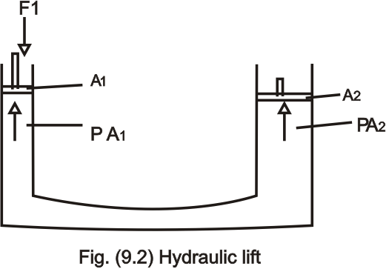

**Figure 2:** Hydraulic lift

From the illustration of Fig. 2, a piston with small cross sectional area A1 exerts a force F1 on the surface of the fluid (liquid). The applied pressure is transmitted through the liquid inside the connecting pipe to a large piston of area A2. The pressure P1 is the same in both the small and larger cylinders.

It follows that:

(13)

**Example 1**

The rock crusher shown in Fig.3 operates in agreement with the principle of Pascal, if a force of 80.0 N is applied to the piston on the smaller cylinder. Evaluate the force on the rock.

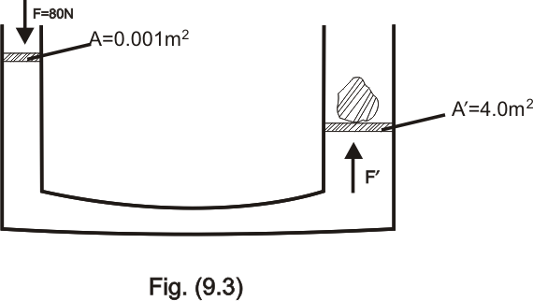

**Figure 3:** Application of hydraulic lift

**Solution**

The pressure exerted by force *F* on the fluid on the smaller cylinder is transmitted undiminished to the larger cylinder, where the force exerted on the larger piston is , then;

The pressure on the smaller piston = the pressure on the larger piston

**Example 2**

A metal block of mass 100 kg, 3.0 m long and with each end cross- sectional area of 30.0 cm2 stands vertically on one end. Calculate the pressure the block exerts on the ground.

**Solution**

**3.3** **Compressible Fluid**

The variation of pressure with altitude in the Earth’s atmosphere can be explained based on the assumption that the air in the atmosphere is **compressible** (i.e fluid whose density changes markedly with depth. e.g air). The atmosphere is at constant temperature and air density is a function of altitude *Y* above the sea level. That is;

(14)

Therefore, the density is directly proportional to the pressure and thus follows that:

(15)

where = and P(0) = P0

Now consider a thin slab of air in Fig.4,

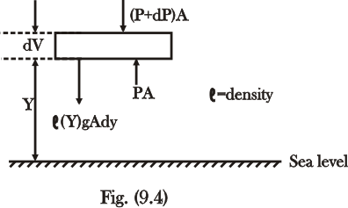

**Figure 4:** Illustration of a thin slab of air

The force equation (with the upward direction positive) is

( )

(16)

We can rewrite equation (15) as

(17)

Substituting the equivalent of in equation (17) into equation (16), we get

Integrating both sides of the above equation, gives

Taking the exponential of both sides of the equation, we have

Therefore,

(18a)

(Isothermal atmosphere) (18b)

where , a constant whose value equals to 0.116. Equation (18) is known as the law of Atmosphere and can be written as

(19)

The altitude (height) term, *Y* is measured in kilometer. Equation (19) implies that pressure decreases with height in the Atmosphere.

**Example 3**

Calculate the distance below the surface of the Earth at which piece of iron (density 7870 kgm-3) will float in air if the density of the air at sea level is 1.3 kgm-3.

**Solution**

Given = 7870 kgm-3 and = 1.3 kgm-3

From equation (15), that is

We can therefore express equation (19) in terms of density like so,

Therefore,

Taking the exponential of both sides of the equation we have

**3.4 Instruments for Measuring Pressure**

The instrument for measuring pressure especially gas pressure is known as the **manometer** (precisely the open- tube manometer) while the instrument for measuring atmospheric pressure is known as **barometer** (mercury barometer) shown in the Fig. 5-6.

**3.4.1 Open – Tube Manometer**

The manometer works based on the principle that the pressure in a column of liquid is directly proportional to the height of the column. The tube contains liquid of density (ρ) (usually mercury or water). One end is connected to the container where the pressure *P* is to be determine (i.e. *A*) and other end is open to the atmosphere at pressure *P*0 = *P*atm.

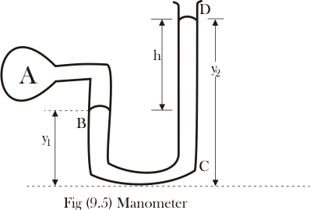

**Figure 5:** Manometer

The pressure at bottom of the tube due to the fluids at point sides (B and D) are same and expressed thus:

At point B, the pressure *P*B is;

(20)

where is the density of the gas of unknown pressure *P*A.

At point C, the pressure *P*C is

(21)

where is the density of the fluid in tube C

Since points B and C are at the same levels, then the pressure at B (*P*B) is equal to the pressure at C (*P*C), i.e. *P*B = *P*C . This implies that

(22)

(23)

where

The excess pressure above the atmosphere pressure is referred to as **gauge pressure** and the total pressure is called **absolute pressure**

In outer space devoid of gases, the pressure is essentially zero. This can be achieve in the laboratory by evacuating the tube (bottle) with the aid of vacuum pump.

Pressure in vacuum is called the **absolute zero.** All pressure referenced with respect to this zero pressure is termed **absolute pressure.**

Most pressure measuring devices uses the atmospheric pressure as reference level and measured the different between absolute pressure and atmospheric pressure. This difference in pressure is known as the **gauge pressure**.

**3.4.2 Mercury Barometer**

It consists of a vertical tube about a metre long, closed at one end that has been filled with mercury (Hg) and then inverted in a dish B of mercury.

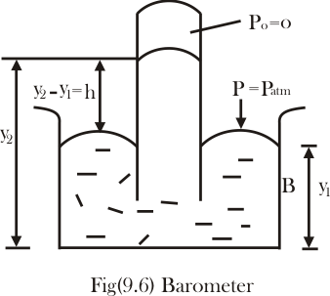

**Figure 6:** Barometer

The pressure on the surface of the mercury in dish B is atmospheric pressure (). The atmospheric pressure exerted on the mercury in dish B, is generally responsible for the extent of rise of mercury in the tube. The height of mercury in the tube is approximately 760 mm above the sea level.

From equation (22) and (23), we can measure the atmospheric pressure,

(24)

Equation (24) implies that mercury barometer reads the atmospheric pressure directly from the height of the mercury column.

A pressure equivalent of that exerted by exactly 760 mm of mercury at 00C temperature under standard gravity g is called one atmosphere (1 *atm*). The density of mercury at this temperature is 13600 . Hence, one atmosphere (1 *atm*) is;

**Example 4**

A typical manometer shown in Fig. 7 uses mercury as its fluid. If the atmospheric pressure is 100 kPa, what is the pressure of the gas in the container on the left, if the density of the gas is 1.29 kg/m3?

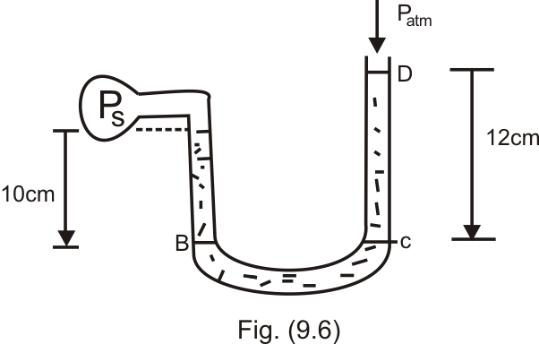

**Figure 7:** Estimating the pressure of an unknown gas using a manometer

**Solution**

Given

y1 = 10 cm = 0.1 m

y2 = 12 cm = 0.12 m

1 = density of gas = 1.29 kg/m3

2 = density of mercury = 13600 kg/m3

Since we have

=

.

**Summary**

So far we have learn the following form this unit:

1. That fluid can either be in form of a liquid or a gas. Also, there are two types of fluid and they are compressible and incompressible fluid.
2. Pressure can be defined as the ratio of force (*F*) to the surface area (*A*) of contact, which is expressed as .
3. For an incompressible fluid with constant density, we can determine the pressure of the liquid at any height using the expression. Likewise, for a compressible fluid e.g. air where the density changes with height we can determine the pressure using the equation .
4. The manometer is used in measuring the pressure of a gas while a barometer is used for measuring atmospheric pressure.

**Self-Assessments**

1. Differentiate between compressible and incompressible fluid.

2. What is the direction of force in the expression of pressure as

2. What do you use the following instrument to measure (i) barometer (ii) manometer ?

3. What do you understand my gauge pressure?

**Tutor Marked Question**

1.The rock crusher shown in Fig.8 operates in agreement with the principle of Pascal, if a force of 150.0 N is applied to the piston on the smaller cylinder. Evaluate the force on the rock.

**Figure 8:** Application of hydraulic lift

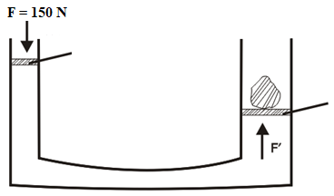

**1.00 cm2**

**4.00**  **cm2**

2. A typical manometer shown in Fig. 9 uses mercury as its fluid. If the atmospheric pressure is 100 kPa, what is the pressure of the gas in the container on the left, if the density of the gas is 1.49 kg/m3?

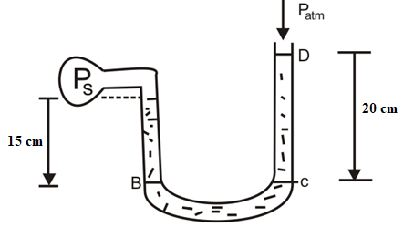

**Figure 9:** Estimating the pressure of an unknown gas using a manometer

**References**

Adams, Steve & Allday, Jonathan (2000). Advanced Physics. UK: Oxford University Press.

Giancoli, D. C. (2008). *Physics for scientists & engineers with modern physics* (Vol. 2). Pearson Education.

Goel , V. K. (2007). Fundamentals of Physics Xi, Tata McGraw-Hill Education

Halliday, D., Resnick, R., & Walker, J. (2013). *Fundamentals of physics*. John Wiley & Sons.

Keith, Gibbs (2011). Advanced Physics (Second Edition). Cambridge University Press.

Michael Browne (2013). Schaum's Outline of Physics for Engineering and Science: 788 Solved Problems + 25 Videos, McGraw-Hill Professional

Nelkon, M & Parker, P (1995) Advanced Level Physics. New Delhi, India: CBS Publishers & Distributors.

Roger Muncaster (1993). A-level Physics, Nelson Thornes

Serway, R. A., & Vuille, C. (2014). *College physics*. Cengage Learning.

Young, H. D., Freedman, R. A., Sandin, T. R., & Ford, A. L. (1996). *University physics* (Vol. 9). Reading, MA: Addison-Wesley.

**Further Reading**

**Unit 2: Fluids in Motion**

1.0 Introduction

2.0 Learning Outcomes

3.0 Main Content

3.1 Fluid

3.1.1 Laminar Flow

3.1.2 Turbulent Flow

3.2 The Equation of Continuity

3.3 Bernoulli’s Equation

3.3.1 Special cases of Bernoulli’s equation

3.3.2 Application of Bernoulli’s equation

3.4 Lack of Blood to the Brain—TIA

3.5 Venturi Tube

4.0 Summary

5.0 Self-Assessment

6.0 Tutor Marked Assignment

7.0 References

8.0 Further Reading

**1.0 Introduction**

This unit focuses on the fluid dynamics and the two major fluid flow types which are the laminar and turbulence flow. The unit also discusses the a certain amount of internal friction called viscosity.

**2.0 Learning Outcomes**

By the end of this lesson, you should be able to:

1. explain the two types of fluid flow
2. derive continuity equation
3. explain the concept of Bernoulli’s principle
4. describes measuring of flow of fluid using a venturi tube
5. explain the physics of blood circulation and Poiseuille's equation

**3.0 Main Content**

**3.1 Fluid**

A fluid *is a system of particles loosely held together by their own cohesive forces or by the restraining forces exerted by the walls of a container.* Both liquids and gases arefluids—liquids are held together by their cohesive forces, and gases are held togetherby the restraining forces of a container (or, in the case of atmospheric air, by theweight of the atmosphere). In contrast to the particles in a rigid body, which are permanentlylocked into fixed positions, the particles in a fluid body are more or lessfree to wander about within the volume of the fluid body. A fluid willchange its shape in response to external forces; for instance, a body of water or a bodyof air will change its shape in response to the forces exerted by gravity and by thecontainer. The difference between these two kinds of fluids is that liquids are nearlyincompressible, whereas gases are compressible. This means that a body of water hasa constant volume independent of the container, whereas a body of air has a variablevolume—the air always spreads out so as to entirely fill the container, and it can bemade to expand or contract by increasing or decreasing the size of the container.

Although a fluid is a system of particles, the number of particles in, say, a cubic centimetre of water is so large that it is not feasible to describe the state of the fluid microscopically, in terms of the masses, positions, and velocities of all the individual particles in the system. Instead, we will describe the fluid in terms of its *density, velocity* *of flow,* and *pressure,* and we will see how the equations governing the statics and the dynamics of a fluid can be expressed in terms of these quantities.

In our discussion, we will neglect some other properties of fluids, such as the *viscosity* and the *surface tension*. Viscosity is an internal friction or stickiness within the fluidthat offers resistance to its flow. For instance, honey is a fluid of high viscosity, whereaswater is a fluid of fairly low viscosity. Surface tension is an elasticity of the exposedsurface of fluid that tends to shrink this surface to a minimum area. Surface tension isresponsible for the formation of drops of water in rain and for the beading of watersplashed on a floor. Viscosity can be neglected when a fluid flows slowly, and surfacetension can be ignored when the fluid has no exposed surface, as in the case of flow incompletely filled pipes.

We now turn to the subject of fluids in motion, which is called fluid dynamics, or (especially if the fluid is water) hydrodynamics. The path followed by a particle of the fluid is called the line of flow of the particle. The two main types of fluid flow are:

1. Laminar or streamline flow, and
2. Turbulence flow

**3.1.1 Laminar Flow**

The word laminar means “in layers”. If the flow of a fluid is steady (also known as streamline flow, steady flow, orderly flow and uniform flow), then all the fluid particles that pass any given point follow the same path at the same speed (i.e. they have the same velocity). Thus, in laminar flow no aspect of the flow pattern changes with time.

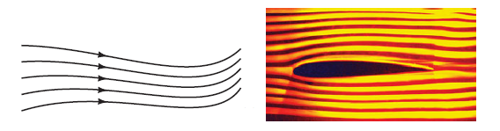

Figure 1: Laminar or streamline flow. The photos show airflow around an airfoil or airplane wing.

We can distinguish two main types of fluid flow. If the flow is smooth, such that neighbouring layers of the fluid slide by each other smoothly, the flow is said to be laminar or streamline flow. In streamline flow, each particle of the fluid follows a smooth path, called a streamline, and these paths do not cross one another (Fig. 1).

**3.1.2 Turbulent Flow**

This is also known as disorderly flow. In this type of flow the speed and the direction of the particles passing any point vary with time.

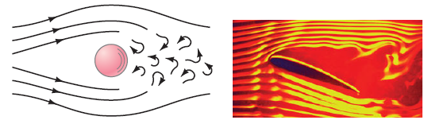

Figure 2: Turbulent flow. The photos show airflow around an airfoil or airplane wing.

Above a certain speed, the flow becomes turbulent. Turbulent flow is characterized by erratic, small, whirlpool-like circles called *eddy currents* or *eddies* (Fig. 2). Eddies absorb a great deal of energy, and although a certain amount of internal friction called viscosity is present even during streamline flow, it is much greater when the flow is turbulent. A few tiny drops of ink or food colouring dropped into a moving liquid can quickly reveal whether the flow is streamline or turbulent.

**3.2 The Equation of Continuity**

Let us consider the steady laminar flow of a fluid through an enclosed tube or pipe as shown in Fig. 3. First we determine how the speed of the fluid changes when the diameter of the tube changes. The mass flow rate is defined as the mass of fluid that passes a given point per unit time:

(1)

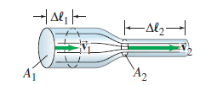

Figure 3: Fluid flow through a pipe of varying diameter.

In Fig. 3, the volume of fluid passing point 1 () through area in a time is where is the distance the fluid moves in time.

Similarly, the velocity of fluid (density) passing point 1 is .

Then the mass flow rate through area is

(2)

where is the volume of mass

Similarly, at point 2 (through area ), the flow rate is . Since no fluid flows in or out the sides of the tube, the flow rates through and must be equal. Thus

and

(3)

This is called the equation of continuity.

If the fluid is incompressible ( doesn’t change with pressure), which is an excellent approximation for liquids under most circumstances (and sometimes for gases as well), then and the equation of continuity becomes

(4)

The product represents the v*olume rate of flo*w (volume of fluid passing a given point per second), since which in SI units is

Equation (4) tells us that where the cross-sectional area is large, the velocity is small, and where the area is small, the velocity is large. That this is reasonable can be seen by looking at a river. A river flows slowly through a meadow where it is broad, but speeds up to torrential speed when passing through a narrow gorge.

**3.3 Bernoulli’s Equation**

Have you ever wondered why an airplane can fly, or how a sailboat can move against the wind? These are examples of a principle worked out by Daniel Bernoulli (1700–1782) concerning fluids in motion. In essence, Bernoulli’s principle states that w*here the* v*elocity of a fluid is high, the pressure is lo*w*, and* w*here the* v*elocity is lo*w*, the pressure is high*. For example, if the pressure in the fluid is measured at points 1 and 2 of Fig. 3, it will be found that the pressure is lower at point 2, where the velocity is greater, than it is at point 1, where the velocity is smaller.

To derive Bernoulli’s equation, we assume the flow is steady and laminar, the fluid is incompressible, and the viscosity is small enough to be ignored. To be general, we assume the fluid is flowing in a tube of non-uniform cross section that varies in height above some reference level, Fig. 4. We will consider the volume of fluid shown in colour and calculate the work done to move it from the position shown in Fig. 4a to that shown in Fig. 4b. In this process, fluid entering area A1 flows a distance and forces the fluid at area A2 to move a distance.

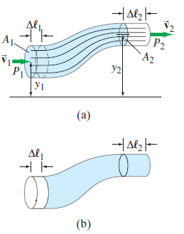

Figure 4: Fluid flow: for derivation of Bernoulli’s equation.

The fluid to the left of area A1 exerts a pressure P1 on our section of fluid and does an amount of work

(5)

At point 2, the work done on our section of fluid is

(6)

The negative sign is present because the force exerted on the fluid is opposite to the displacement. Work is also done on the fluid by the force of gravity and is given by:

(7)

Where and are heights of the center of the tube above some (arbitrary) reference level. In the case shown in Fig. 4, this term is negative since the motion is uphill against the force of gravity. From the equation (5 to 7), the net work *W* done on the fluid is thus

(8)

(9)

According to the work-energy principle, the net work done on a system is equal to its change in kinetic energy. Hence

(10)

The m has the volume for an incompressible fluid. Thus we can substitute , and then divide through by , to obtain

(11)

Rearranging we have,

(12)

Eq.12 is the Bernoulli’s equation. Since points 1 and 2 can be any two points along a

tube of flow, Bernoulli’s equation can be written as

constant (13)

at every point in the fluid, where *y* is the height of the center of the tube above a fixed reference level. [Note that if there is no flow then Eq. 12 reduces to the hydrostatic equation,

(14)

Bernoulli’s equation is therefore an expression of the law of energy conservation, since we derived it from the work-energy principle.

**3.3.1 Special cases of Bernoulli’s equation**

***Case one: when***

Bernoulli’s equation can be applied to many situations. One example is to calculate the velocity, of a liquid flowing out of a spigot at the bottom of a reservoir, Fig. 5.

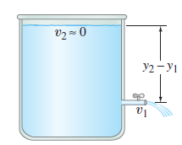

Figure 5: Torricelli’s theorem:

We choose point 2 in Eq. 12 to be the top surface of the liquid. Assuming the diameter of the reservoir is large compared to that of the spigot, will be almost zero. Points 1 (the spigot) and 2 (top surface) are open to the atmosphere, so the pressure at both points is equal to atmospheric pressure: . Then Bernoulli’s equation becomes

(15a)

or

(15b)

This resulted equation is called Torricelli’s theorem. This equation was discovered by Evangelista Torricelli. Equation 15b tells us that the liquid leaves the spigot with the same speed that a freely falling object would attain if falling from the same height.

***Case two: when***

Another special case of Bernoulli’s equation arises when a fluid is flowing horizontally with no appreciable change in height; that is, Then Eq. 12 becomes

(16)

which tells us quantitatively that the speed is high where the pressure is low, and vice versa. It explains many common phenomena, some of which are explained in the next section.

**3.3.2 Application of Bernoulli’s equation**

1. Sprayer or Atomizer

The pressure in the air blown at high speed across the top of the vertical tube of a perfume atomizer (Fig. 6) is less than the normal air pressure acting on the surface of the liquid in the bowl. Thus atmospheric pressure in the bowl pushes the perfume up the tube because of the lower pressure at the top.

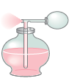

Figure 6: An atomizer

2. Ping-Pong ball in jet of air

A Ping-Pong ball can be made to float above a blowing jet of air (a hair dryer or a vacuum cleaner that can also blow air) as shown in Fig. 7. If the ball begins to leave the jet of air, the higher pressure in the still air (atmospheric pressure) outside the jet pushes the ball back into the region of lower pressure that is into the stream.

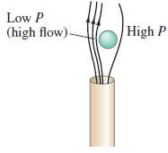

Figure 7: Ping-Pong ball in jet of air.

Similarly, when a ping-pong ball is placed on a vertical stream of water-fountain above its nozzle, the ball rises up to a height and spins up and down without falling.

3. Aero foil: Dynamic Lift on an Aeroplane wing

The wing of an aircraft is designed to cause dynamic uplift by virtue of its horizontal motion through air. This upward force makes aeroplanes fly.

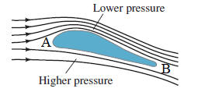

Figure 8: A section of a wing of an aeroplane. The upper surface of the wing is more curved than the lower surface and the front edge *A* (i.e. head) is broader (round shaped) than its rear edge *B* which is flattened.

As the aeroplane moves forward to fly, the flow of air above and below the wing is streamlined. The streamlines of air-flow are curved around the wing at A and meet at B at the same time. The upward tilt, as well as the rounded upper surface of the wing, causes the streamlines to be forced upward and to be crowded together above the wing. The area of air flowing between any two streamlines is smaller as the streamlines get closer together, so from the equation of continuity the air speed increases above the wing where the streamlines are squished together. Thus the air speed is greater above the wing than below it, so the pressure above the wing is less than the pressure below the wing (Bernoulli’s principle). Hence there is a net upward force on the wing called dynamic lift. Experiments show that the speed of air above the wing can even be double the speed of the air below it. (Friction between the air and wing exerts a *drag force*, toward the rear, which must be overcome by the plane’s engines).

4. Sailboats

A sailboat can move “against” the wind, with the aid of the Bernoulli effect, by setting the sails at an angle, as shown in Fig. 9.

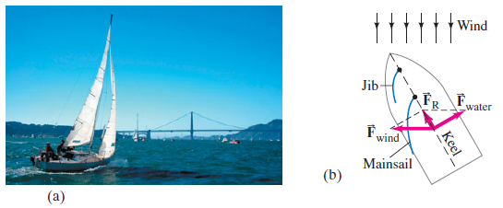

Figure 9: Sailboat (a) sailing against the wind with (b) analysis.

The air traveling rapidly over the bulging front surface of the mainsail exerts a smaller pressure than the relatively still air behind the sail. The result is a net force on the sail, as shown in Fig. 9b. This force would tend to make the boat move sideways if it weren’t for the keel that extends vertically downward beneath the water: the water exerts a force ( on the keel nearly perpendicular to the keel. The resultant of these two forces () is almost directly forward as shown.

5. Baseball Curve

Why a spinning pitched baseball (or tennis ball) curves can also be explained using Bernoulli’s principle. It is simplest if we put ourselves in the reference frame of the ball, with the air rushing by, just as we did for the airplane wing. Suppose the ball is rotating counter clockwise as show in Fig. 10. A thin layer of air (“boundary layer”) is being dragged around by the ball.

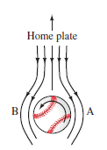

Figure 10: Looking down on a pitched baseball heading toward home plate. We are in the reference frame of the baseball, with the air flowing by.

We are looking down on the ball, and at point A in Fig. 10, this boundary layer tends to slow down the oncoming air. At point B, the air rotating with the ball adds its speed to that of the oncoming air, so the air speed is higher at B than at A. The higher speed at B means the pressure is lower at B than at A, resulting in a net force toward B. The ball’s path curves toward the left (as seen by the pitcher).

**3.4 Lack of Blood to the Brain—TIA**

In medicine, one of many applications of Bernoulli’s principle is to explain a TIA, a *transient ischemic attack* (meaning a temporary lack of blood supply to the brain). A person suffering a TIA may experience symptoms such as dizziness, double vision, headache, and weakness of the limbs. A TIA can occur as follows. Blood normally flows up to the brain at the back of the head via the two vertebral arteries—one going up each side of the neck—which meet to form the basilar artery just below the brain, as shown in Fig. 11. Each vertebral artery connects to the subclavian artery, as shown, before the blood passes to the arms. When an arm is exercised vigorously, blood flow increases to meet the needs of the arm’s muscles. If the subclavian artery on one side of the body is partially blocked, however, as in arteriosclerosis (hardening of the arteries), the blood velocity will have to be higher on that side to supply the needed blood (Recall the equation of continuity: smaller area means larger velocity for the same flow rate, Eq. 4).

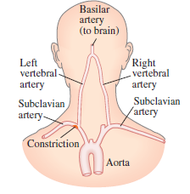

Figure 11: Rear of the head and shoulders showing arteries leading to the brain and to the arms. High blood velocity past the constriction in the left subclavian artery causes low pressure in the left vertebral artery, in which a reverse (downward) blood flow can then occur, resulting in a TIA, a loss of blood to the brain.

The increased blood velocity past the opening to the vertebral artery results in lower pressure (Bernoulli’s principle). Thus, blood rising in the vertebral artery on the “good” side at normal pressure can be *di*v*erted do*w*n* into the other vertebral artery because of the low pressure on that side, instead of passing upward to the brain. Hence the blood supply to the brain is reduced.

**3.5 Venturi Tube**

A venturi tube is essentially a pipe with a narrow constriction (the throat). The flowing fluid speeds up as it passes through this constriction, so the pressure is lower in the throat. A venturi meter, Fig.12, is used to measure the flow speed of gases and liquids, including blood velocity in arteries. The velocity can be determined by measuring the pressure and the areas and, as well as the density of the fluid.

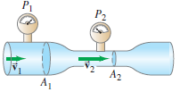

Figure 12: Venturi meter

**Worked Example**

In humans, blood flows from the heart into the aorta, from which it passes into the major arteries, Fig. 13. These branch into the small arteries (arterioles), which in turn branches into myriads of tiny capillaries. The blood returns to the heart via the veins. The radius of the aorta is about 1.2 cm, and the blood passing through it has a speed of about 40 cm/s. A typical capillary has a radius of about 4 x 10-4 cm, and blood flows through it at a speed of about 5 x 10-4 m/s. Estimate the number of capillaries that are in the body.

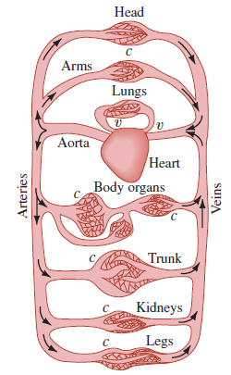

Figure 13: Human circulatory system

**Solution**

Let A1 be the area of the aorta and A2 be the area of *all* the capillaries through which blood flows. Then , where is the estimated average radius of one capillary. From the equation of continuity, we have

So

or on the order of 10 billion capillaries.

**Example 2**

What area must a heating duct have if air moving 3.0 m/s along it can replenish the air every 15 minutes in a room of volume 300 m3?Assume the air’s density remains constant.

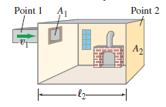

Figure 14: An Illustration of Example

**Solution**

Consider the room as a large section of the duct, Fig. 14, and think of air equal to the volume of the room as passing by point 2 in *t* = 15 min = 900 s. Reasoning in the same way we did to obtain Eq. 3 (changing to *t*), we write so where V2 is the volume of the room. Then the equation of continuity becomes and

Note If the duct is square, then each side has length or 33 cm. A rectangular duct 20 cm x 55 cm will also do.

**4.0 Summary**

In this unit you have learnt that:

1. fluid can be a liquid or gas
2. there are two types of fluid flow and they are the laminar or streamline flow and turbulence flow
3. from continuity equation, equation (4) tells us that when the cross-sectional area is large, the velocity is small, and where the area is small, the velocity is large.
4. The expression for Bernoulli’s equation is
5. application of Bernoulli’s equation

**5.0 Self-Assessment**

1. Differentiate between Laminar flow and turbulence flow
2. What are the application of Bernoulli's principle

**6.0 Tutor Marked Assignment**

1. Derive the Bernoulli’s equation for the cases (i) when P1 = P2 and (ii) when y1= y2, where y1 and y2 are heights of the center of the tube above some (arbitrary) reference level.
2. 2.You are expected to be able to answer the following questions using the Continuity equation (Eq. 4) and Bernoulli’s equation (Eq. 12).
3. Why does smoke go up a chimney?
4. How are gophers, prairie dogs, rabbits, and other animals that live underground are able to avoid suffocation in their burrows.
5. Blowing off the roof a hut or tinned roof during storm
6. Water circulates throughout a house in a hot-water heating system. If the water is pumped at a speed of 0.50 m/s through a 4.0 cm diameter pipe in the basement under a pressure of 3.0 atm, what will be the flow speed and pressure in a 2.6 cm diameter pipe on the second floor 5.0 m above? Assume the pipes do not divide into branches.

**7.0 Reference**

Adams, Steve & Allday, Jonathan (2000). Advanced Physics. UK: Oxford University Press.

Giancoli, D. C. (2008). *Physics for scientists & engineers with modern physics* (Vol. 2). Pearson Education.

Goel , V. K. (2007). Fundamentals of Physics Xi, Tata McGraw-Hill Education

Halliday, D., Resnick, R., & Walker, J. (2013). *Fundamentals of physics*. John Wiley & Sons.

Keith, Gibbs (2011). Advanced Physics (Second Edition). Cambridge University Press.

Michael Browne (2013). Schaum's Outline of Physics for Engineering and Science: 788 Solved Problems + 25 Videos, McGraw-Hill Professional

Nelkon, M & Parker, P (1995) Advanced Level Physics. New Delhi, India: CBS Publishers & Distributors.

Roger Muncaster (1993). A-level Physics, Nelson Thornes

Serway, R. A., & Vuille, C. (2014). *College physics*. Cengage Learning.

Young, H. D., Freedman, R. A., Sandin, T. R., & Ford, A. L. (1996). *University physics* (Vol. 9). Reading, MA: Addison-Wesley.

**8.0 Further Reading**

**Unit 3: Viscosity**

1.0 Introduction

2.0 Learning Objectives

3.0 Main Content

3.1 Viscosity

3.2 Flow in Tubes: Poiseuille’s Equation

4.0 Summary

5.0 Self- Assessments

6.0 Tutor Marked Assignment

7.0 References

8.0 Further Reading

**1.0 Introduction**

In our discussion of fluid flow in the preceding units, we have explained fluid as if fluid had no internal friction. However, in some fluid the effect of internal friction which is known as viscosity is important. In this unit we shall discuss the force require to keep an object moving a viscous fluid and also explain the Poiseuille equation for determine the volume of liquid flowing in a tube as a function time.

**2.0 Learning Objectives**

By the end of this note, you should be able to:

* explain viscosity
* applied the mathematical expression of viscosity
* explain the physics of fluid flow using Poiseuille's equation

**3.0 Main Content**

**3.1 Viscosity**

Real fluids have a certain amount of internal friction called viscosity. Viscosity exists in both liquids and gases, and is essentially a frictional force between adjacent layers of fluid as the layers move past one another. In liquids, viscosity is due to the electrical cohesive forces between the molecules. In gases, it arises from collisions between the molecules.

The viscosity of different fluids can be expressed quantitatively by a *coefficient* *of* v*iscosity*, ɳ (the Greek lowercase letter eta), which is defined in the following way. A thin layer of fluid is placed between two flat plates. One plate is stationary and the other is made to move, Fig. 1.

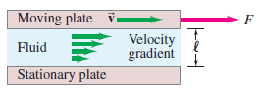

Figure 1: Determination of viscosity.

The fluid directly in contact with each plate is held to the surface by the adhesive force between the molecules of the liquid and those of the plate. Thus the upper surface of the fluid moves with the same speed as the upper plate, whereas the fluid in contact with the stationary plate remains stationary. The stationary layer of fluid retards the flow of the layer just above it, which in turn retards the flow of the next layer, and so on. Thus the velocity varies continuously from 0 to *,* as shown. The increase in velocity divided by the distance over which this change is made—equal to —is called the v*elocity gradient*. To move the upper plate requires a force, which you can verify by moving a flat plate across a puddle of syrup on a table. For a given fluid, it is found that the force required, *F*, is proportional to the area of fluid in contact with each plate, *A*, and to the speed, v*,* and is inversely proportional to the separation, , of the plates: . For different fluids, the more viscous the fluid, the greater is the required force. The proportionality constant for this equation is defined as the coefficient of viscosity, ɳ:

(1)

Solving for ɳ, we find The SI unit for ɳ is N.s/m2 = Pa.s (pascal.second).

In the cgs system, the unit is which is called poise(P). Viscosities are often given in centipoise (1 cP = 10-2P = 10-3Pa.s).

Table 1 lists the coefficient of viscosity for various fluids. The temperature is also specified, since it has a strong effect; the viscosity of liquids such as motor oil, for example, decreases rapidly as temperature increases.

Table 1: Coefficients of Viscosity

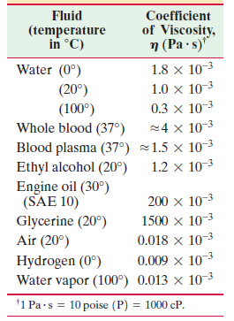

**Example 1**

A plate of area 10 cm2 is separated from a large plate by a layer of glycerine 1 mm thick. If the viscous coefficient of glycerine is 20 poise, what force is required to keep the plate moving with velocity of 1 cms-1?

**Solution**

Given:

*A* = 10 cm2

Using equation (1)

**3.2 Flow in Tubes: Poiseuille’s Equation**

If a fluid had no viscosity, it could flow through a level tube or pipe without a force being applied. Viscosity acts like a sort of friction (between fluid layers moving at slightly different speeds), so a pressure difference between the ends of a level tube is necessary for the steady flow of any real fluid, be it water or oil in a pipe, or blood in the circulatory system of a human.

The French scientist J. L. Poiseuille (1799–1869), who was interested in the physics of blood circulation (and after whom the “poise” is named), determined how the variables affect the flow rate of an incompressible fluid undergoing laminar flow in a cylindrical tube. His result, known as Poiseuille’s equation, is:

(2a)

(2b)

where *R* is the inside radius of the tube, 𝓁 is the tube length, is the pressure difference between the ends, ɳ is the coefficient of viscosity, and *V* is the volume rate of flow (volume of fluid flowing past a given point per unit time which in SI has units of m3/s ).

We use equation (2a) if there is a pressure difference between the ends of the tube. However, if the pressure is constant, equation (2b) is used. In addition, equation (2) applies only to laminar (streamline) flow.

Poiseuille’s equation tells us that the flow rate *V* is directly proportional to the “pressure gradient,” and it is inversely proportional to the viscosity of the fluid. This is just what we might expect. It may be surprising, however, that *V* also depends on the *fourth* power of the tube’s radius. This means that for the same pressure gradient, if the tube radius is halved, the flow rate is decreased by a factor of 16! Thus the rate of flow, or alternately the pressure required to maintain a given flow rate, is greatly affected by only a small change in tube radius.

**Example 2**

Calculate the mass of water flowing in 10 minutes through a tube of 0.1 cm in diameter, 40 cm long, if there is a constant pressure height of 20 cm of water. The coefficients of viscosity for water is Nsm-2 ( Take acceleration due to gravity = 9.8 Nm-2).

**Solution**

Given:

Coefficients of viscosity for water is Nsm-2

Length,

Diameter is 0.1 cm =

From Unit 1, equation (2b), pressure is expressed as

*h* is given from the question as 20 cm  *=*

Density of water,  *=* 1000 kgm-3

g = 9.8 Nm-2

Therefore, Nm-2

We can now substitute all these variables into equation (2b) to calculate the volume of water flow rate (*V*) per seconds, so we have

To calculate the volume of water flown in 10 minutes, we will need to convert 10 minutes to seconds,

1 minutes = 60 seconds

Therefore 10 minutes = 600 seconds

Volume of water flown in 10 minutes (600 seconds)

=

We can now calculate the mass of water flown in 10 minutes using equation (3) of unit 1,

We have

**4.0 Summary**

In this unit you have learnt:

1. viscosity is the name giving to the internal friction in a fluid.
2. The symbol of coefficient of viscosity is ɳ (pronounced as ‘eta’) and can be calculated from the expression .
3. That the volume of rate of flow of a fluid can be calculated using Poiseuille's equation:

**5.0 Self-Assessments**

1. Define viscosity.
2. Write an expression to describe the coefficient of viscosity.
3. What can you deduce from Poiseuille’s equation?

**6.0 Tutor Marked Assignment**

1. In an experiment with Poiseuille’s experiment, the following readings were obtained.

Volume of the liquid flowing per minute = 10-5 m3

Density of the liquid =

Length of the tube = 0.005 cm and radius of the tube is 0.05 cm

Height of the fluid head = 0.006 cm.

Determine the coefficient of viscosity for the liquid.

**7.0 References**

Adams, Steve & Allday, Jonathan (2000). Advanced Physics. UK: Oxford University Press.

Giancoli, D. C. (2008). *Physics for scientists & engineers with modern physics* (Vol. 2). Pearson Education.

Goel , V. K. (2007). Fundamentals of Physics Xi, Tata McGraw-Hill Education

Halliday, D., Resnick, R., & Walker, J. (2013). *Fundamentals of physics*. John Wiley & Sons.

Keith, Gibbs (2011). Advanced Physics (Second Edition). Cambridge University Press.

Michael Browne (2013). Schaum's Outline of Physics for Engineering and Science: 788 Solved Problems + 25 Videos, McGraw-Hill Professional

Nelkon, M & Parker, P (1995) Advanced Level Physics. New Delhi, India: CBS Publishers & Distributors.

Roger Muncaster (1993). A-level Physics, Nelson Thornes

Serway, R. A., & Vuille, C. (2014). *College physics*. Cengage Learning.

Young, H. D., Freedman, R. A., Sandin, T. R., & Ford, A. L. (1996). *University physics* (Vol. 9). Reading, MA: Addison-Wesley.

**8.0 Further Reading**

**Unit 4: Stoke’s Law**

1.0 Introduction

2.0 Learning Objectives

3.0 Main Content

3.1 Stokes’s Law

3.1.1 Derivation of Stoke’s Law

3.1.2 Application of Stokes Law

3.2 Terminal Velocity

4.0 Summary

5.0 Self- Assessments

6.0 Tutor Marked Assignment

7.0 References

8. Further Reading

**1.0 Introduction**

This unit focuses on the motion of solid object in a fluid govern by Stoke’s law. This unit shall also discuss the property of a liquid surface.

**2.0 Learning Objectives**

By the end of this note, you should be able to:

1. derive Stoke’s Law
2. explain the applications of Stoke’ Law
3. explain terminal velocity of sphere falling from rest through a viscous fluid

**3.0 Main Content**

**3.1 Stokes’s Law**

When a solid object falls through a fluid (liquid or gas), it drags the layers of fluid with it downward. The layer of the fluid in contact with the object moves with the velocity of the object. Thus, the motion of the object produces a relative motion between the different layers of the fluid. Consequently, a backward dragging force (viscous force) opposes the motion of the object. This viscous force increases with increase in the velocity of the falling object and ultimately becomes equal to the effective force (i.e. weight) driving the object. In this position, the object falls with a constant velocity called terminal velocity.

Sir George Stokes made series of experiment on the motion of small spherical objects in different fluids. He showed that when a small spherical object of radius *r*moves with a small uniform (terminal) velocity through a perfectly homogeneous fluid of coefficient of viscosity ɳ, then the retarding viscous force experienced by the object is given by

This relation is known a Stoke’s law of viscosity.

In order to arrive at the above relations, Stokes made the following assumptions:

1. The spherical object should be small, perfectly rigid and smooth.
2. The fluid through which the body falls should be infinitely extensive and perfectly homogeneous.
3. The object should move slowly so that the motion of the fluid in contact with the body remains streamlined.

**3.1.1 Derivation of Stoke’s Law**

Consider a sphere of radius r moving with a velocity through a fluid whose coefficient of viscosity is ɳ. The sphere experiences a viscous force *F* which acts in the opposite direction to that in which the sphere is moving. The Stoke’s law can be easily derived by the method of dimensions.

Let is put the relation as

or (1)

where *a*, *b* and *c* are the dimension of *F* in terms of ɳ, *r* and respectively and *k* is a dimensionless constant.

Equating the indices of M, L and T on both sides gives

(2)

(3)

(4)

From the equations (2) and (4), we have

Putting the values of *a* and *c* in Eq. (3), we get

Thus *a* = 1, *b* = 1 and *c* = 1

Substituting the values of *a*, *b* and *c* in equation (1), we have

Stokes showed that if the medium is of infinite extension, then value of the constant of proportionality.

Therefore,

(5)

**3.1.2 Application of Stokes Law**

1. Stoke’s law is used in Millikan’s experiment for determining the electronic charge.
2. This law accounts for the formation of clouds. When the water vapour present in air gets condensed on dust particles, small drops of rain water are formed. But their weight is very small. The terminal velocity which they acquire in air is also very small, so they float in the sky as clouds.
3. This law helps a person to reach safely on earth, while jumping from a flying aeroplane with the help of a parachute.
4. Viscosity of highly viscous fluid like glycerine and track can be easily compared using Stoke’s law.

**3.2 Terminal Velocity**

Consider a sphere falling from rest through a viscous fluid. The forces acting on the sphere are its weight *W*, the upthrust *U* due to the displaced fluid, and the viscous drag.

Upthrust (*U*) +

Viscous drag ()

Sphere falling

through a

viscous

fluid

Weight (*W*)

Initially the downward force *W* is greater than the upward force, *U* + , and the sphere accelerates downwards. As the velocity of the sphere increases so does the viscous drag, and eventually *U* + is equal to *W*. The sphere continues to move downwards but, because there is now no net force acting on it, its velocity has a constant maximum value known as its terminal velocity.

1. True weight of the body (*W*) acting vertically downwards,

1. Upward thrust, due to buoyancy of the fluid displaced, acting vertically upwards,

= Weight of fluid displaced

= mg

= volume of fluid displaced **×** density **×** g

where and are densities of the fluid and the sphere respectively.

1. Retarding viscous force of fluid, , acting vertically upwards opposite to the motion of the body

Where is the coefficient of viscosity of the fluid

At the terminal velocity

(6)

Substituting for *W*, *U*, and in Eq. 6, gives

(7)

**Example**

A ball bearing of radius 1.0 **×** 10-3 m and density 1.0 **×** 104 kg/m3 enters a tank of water, after a free fall through a distance h in the earth’s gravitational field. If its velocity remains unchanged after entering water, determine the value of h. Given coefficient of viscosity of water = 1.0 **×** 10-5 Ns/m2 or kg/m3, density of water = 1.0 **×** 103 kg/m3 and g = 10 ms-2.

**Solution**

Given radius of sphere, *r* = 1.0 **×** 10-4 m,

Density of sphere = 1.0 **×** 104 kg/m3 = 10 **×** 103 kg/m3,

Density of water = 1.0 **×**103 kg/m3, Coefficient of viscosity = 1.0 **×**10-5 Ns/m2

Using equation (7), terminal velocity of the ball bearing falling in the fluid

Putting the given values, we have

= 20 m/s

Now using the relation and putting u = 0, we have

Therefore,

**4.0 Summary**

In this unit you have learnt:

1. how to derive the expression of Stoke’s law:
2. the various applications of Stoke’s law such as in d determining the electronic charge using Millikan’s experiment and alos in explaining the comcept of formation of cloud
3. concept of terminal velocity and the equation of terminal velocity is

**5.0 Self-Assessments**

1. Write the equation to describe Stoke’s Law of viscosity
2. State three (3) applications of Stoke’s Law
3. Explain Stokes law and explain the conditions under which a rain drop attains terminal velocity, .
4. Give the expression for

**6.0 Tutor Marked Assignment**

1. Determine the radius of the drop of water falling through air, if the terminal velocity of the drop is 1.2 cms-1, for air 18 10-5 Nsm-2 and density of air 1.21 kgm-3.
2. The terminal velocity o f a rain drop is 30 cms-1. Taking the viscosity of air as 1.8 10-5 Nsm-2, what is the radius of the rain drop?

**7.0 References**

Adams, Steve & Allday, Jonathan (2000). Advanced Physics. UK: Oxford University Press.

Giancoli, D. C. (2008). *Physics for scientists & engineers with modern physics* (Vol. 2). Pearson Education.

Goel , V. K. (2007). Fundamentals of Physics Xi, Tata McGraw-Hill Education

Halliday, D., Resnick, R., & Walker, J. (2013). *Fundamentals of physics*. John Wiley & Sons.

Keith, Gibbs (2011). Advanced Physics (Second Edition). Cambridge University Press.

Michael Browne (2013). Schaum's Outline of Physics for Engineering and Science: 788 Solved Problems + 25 Videos, McGraw-Hill Professional

Nelkon, M & Parker, P (1995) Advanced Level Physics. New Delhi, India: CBS Publishers & Distributors.

Roger Muncaster (1993). A-level Physics, Nelson Thornes

Serway, R. A., & Vuille, C. (2014). *College physics*. Cengage Learning.

Young, H. D., Freedman, R. A., Sandin, T. R., & Ford, A. L. (1996). *University physics* (Vol. 9). Reading, MA: Addison-Wesley.

**8.0 Further Reading**

**Unit 5: Surface Tension**

1.0 Introduction

2.0 Learning Objectives

3.0 Main Content

3.1 Surface Tension

3.1.1 Effect of Surface Tension

3.1.2 Floating objects and surface tension

3.2 Capillarity

3.3 Contact angles

4.0 Summary

5.0 Self-Assessments

6.0 Tutor Marked Assignment

7.0 References

8.0 6.0 Further Reading

**Introduction**

Do you know that a glass of water can be over filled so that the water level is higher than the glass and yet the remain in the glass. This description can be said to defy gravitational pull and thus indicating that a force exist that want to keep the water together. This force is what is known as surface tension. In this unit, we shall explain surface tension and its application to physical observation.

**2.0 Learning Objectives**

By the end of this note, you should be able to:

1. explain surface tension
2. differentiate between adhesive and cohesive force
3. apply the expressions of surface tension to solve physical problems
4. describes the physics of capillarity
5. explain contact angle

**3.0 Main Content**

**3.1 Surface Tension**

Surface Tension is the property of a liquid surface that causes it to act like a stretched elastic membrane. Its strength depends on the forces of attraction among the particles of the liquid itself and with the particles of the gas, solid, or liquid with which it comes in contact. Surface tension allows certain insects to stand on the surface of water and can support a razor blade placed horizontally on the liquid's surface, even though the blade may be denser than the liquid and unable to float. Surface tension results in spherical drops of liquid, as the liquid tends to minimize its surface area. This effect is called surface tension. More specifically, a quantity called the *surface tension*, (the Greek letter gamma), is defined as the force *F* per unit length that acts perpendicular to any line or cut in a liquid surface, tending to pull the surface closed:

(1)

At liquid-air interfaces, surface tension results from the greater attraction of water molecules to each other (due to cohesion) than to the molecules in the air (due to adhesion). The net effect is an inward force at its surface that causes water to behave as if its surface were covered with a stretched elastic membrane. Because of the relatively high attraction of water molecules for each other, water has a high surface tension (0.072 N/m at 20°C) compared to that of most other liquids. Surface tension is an important factor in the phenomenon of capillarity.

**3.3.1 Effect of Surface Tension**

Beading of rain water on a waxy surface, such as a leaf. Water adheres weakly to wax and

strongly to itself, so water clusters into drops. Surface tension gives them their near-spherical

shape, because a sphere has the smallest possible surface area to volume ratio.



**Figure 1:** Spherical water droplets, dew on a blade of grass.

Similar example is a drop of water on the end of a dripping faucet forms into a nearly spherical shape as if it were a tiny balloon filled with water.

Because of surface tension, some insects (Fig. 2a) can walk on water, and objects more dense than water, such as a paper clip (Fig. 2b), can float on the surface. 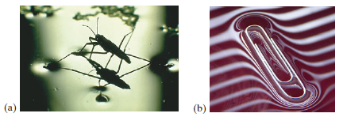

**Figure** **2** (a) Water strider. (b) Paper clip (light coming through window blinds).

**3.3.2 Floating objects and surface tension**

When an object is placed on a liquid, its weight *Fw* depresses the surface, and is balanced by the surface tension forces on either side *Fs*, which are each parallel to the water's surface at the points where it contacts the object. Notice that the horizontal components of the two *Fs* arrows point in opposite directions, so they cancel each other, but the vertical components point in the same direction and therefore add up to balance *Fw.*

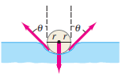

**Fs**

**Fs**

**Fw**

**Figure 3:** Surface tension acting on sphere

**3.4 Capillarity**

Surface tension plays a role in another interesting phenomenon, *capillarity*. It is a common observation that water in a glass container rises up slightly where it touches the glass, Fig. 4a. The water is said to “wet” the glass. Mercury, on the other hand, is depressed when it touches the glass, Fig. 4b; the mercury does not wet the glass. Whether a liquid wets a solid surface is determined by the relative strength of the cohesive forces between the molecules of the liquid compared to the adhesive forces between the molecules of the liquid and those of the container. Cohesionrefers to the force between molecules of the same type, whereas adhesionrefers to the force between molecules of different types. Water wets glass because the water molecules are more strongly attracted to the glass molecules than they are to other water molecules. The opposite is true for mercury: the cohesive forces are stronger than the adhesive forces.

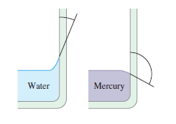

**θ**

**θ**

**(a)**

**(b)**

**θ < 90°**

**θ > 90°**

**Figure 4:** (a) Water “wets” the surface of glass, whereas (b) mercury does not “wet” the glass.

In tubes having very small diameters, liquids are observed to rise or fall relative to the level of the surrounding liquid. This phenomenon is called capillarity, and such thin tubes are called capillaries. Whether the liquid rises or falls (Fig. 5) depends on the relative strengths of the adhesive and cohesive forces. Thus water rises in a glass tube, whereas mercury falls. The actual amount of rise (or fall) depends on the surface tension—which is what keeps the liquid surface from breaking apart.

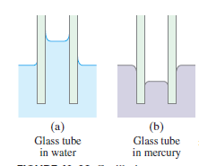

**Figure 5:** Capillarity.

**3.5 Contact angles**

Where the two surfaces meet, they form a contact angle θ, which is the angle the tangent to the surface makes with the solid surface. The diagram to the right shows two examples. Tension forces are as shown in the Fig.4-5. The liquid surface is called meniscus which may curve downwards or upwards depending on which of the two forces (cohesive or adhesive forces) dominates.

1. If cohesive force < adhesive force

Contact angle θ < 90°: we have concave meniscus, i.e. meniscus curves upward (see Figure 4a).

1. If cohesive force > adhesive force

Contact angle θ > 90°: we have convex meniscus, i.e. meniscus curves upward (see Figure 4b).

If a very thin test tube is inserted in a liquid reservoir, there is a different between the levels of the liquid inside and outside the tube.

If θ < 90°, liquid level rises higher inside the tube e.g. water in a glass tube.

If θ > 90°, liquid level depresses inside the tube e.g. mercury-in-glass tube.

Let us consider an object rested on the surface of a liquid as shown in Fig. 6. Two forces act on the tube inside the liquid:

1. Upward force *F* due to surface tension which acts around the circles of contact between the meniscus and the glass tube.
2. The downward pull of gravity *Fw* (weight of the liquid column)

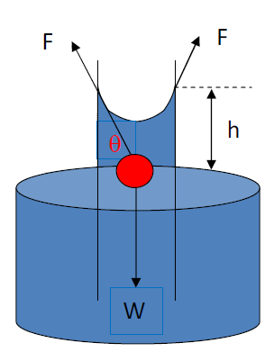

Figure 6: Surface tension acting on a sphere

At equilibrium

(2)

Recall the expression of surface tension from equation(1) is given as

where is the circumference of the circle of contact angle along which the surface tension acts. Therefore,

(3)

Put equation (3) into (2), we get

(4)

But,

(5)

where is the volume of the liquid (i.e area height), *r* is the radius of the tube.

Substitute equation (5) into (4), we have

(6)

By rearranging, we have

(4)

*h* varies inversely with the radius of the tube.

**Example**

The shape of a typical insect is spherical in shape with a radius of 2.0 x 10-5m. the 3 kg mass of the insect is supported equally by its six legs. Calculate the contact angle θ for an insect floating on the surface of water.

**Solution**

Given:

*r* **=** 2.0 x 10-5m

*m* = 0.0030 g = 3 x 10-6 kg

g = 9.8 ms-2

= 0.072 Nm-1

The insect is in equilibrium and this implies that

Upward surface tension = downward gravity pull

That is, (from equation (4))

Since the insect has six legs, the surface tension force equal to one-sixth the weight of the insect for this case. We then have,

**4.0 Summary**

In this unit you have learnt about:

1. surface tension is the property of a liquid surface that causes it to act like a stretched elastic membrane and is express as
2. cohesive forces are the forces of attraction between the molecules of the same substance while adhesive forces are forces of attraction between the molecules of different substance.
3. balances of forces between upward surface tension and downward gravitational force in solving physical problems.
4. capillarity as a phenomenon that describes the to rise or fall of a liquid ina narrow tube relative to the level of the surrounding liquid.
5. contact angle and its implications on the direction of the meniscus of a fluid.

**5.0 Self-Assessments**

1. What are the effects of surface tension?
2. Why does water wet glass?
3. If cohesive force > adhesive force. What is the contact angle?
4. If cohesive force < adhesive force. What is the contact angle?

**6.0 Tutor Marked Assignment**

1. Explain why the angle of contact of mercury with glass is obtuse, while that of water with glass is acute.
2. A 3.03 g sphere of 3 cm radius is rested flat on the surface of a liquid and then raised. Calculate the surface tension of the liquid.

**7.0 References**

Adams, Steve & Allday, Jonathan (2000). Advanced Physics. UK: Oxford University Press.

Giancoli, D. C. (2008). *Physics for scientists & engineers with modern physics* (Vol. 2). Pearson Education.

Goel , V. K. (2007). Fundamentals of Physics Xi, Tata McGraw-Hill Education

Halliday, D., Resnick, R., & Walker, J. (2013). *Fundamentals of physics*. John Wiley & Sons.

Keith, Gibbs (2011). Advanced Physics (Second Edition). Cambridge University Press.

Michael Browne (2013). Schaum's Outline of Physics for Engineering and Science: 788 Solved Problems + 25 Videos, McGraw-Hill Professional

Nelkon, M & Parker, P (1995) Advanced Level Physics. New Delhi, India: CBS Publishers & Distributors.

Roger Muncaster (1993). A-level Physics, Nelson Thornes

Serway, R. A., & Vuille, C. (2014). *College physics*. Cengage Learning.

Young, H. D., Freedman, R. A., Sandin, T. R., & Ford, A. L. (1996). *University physics* (Vol. 9). Reading, MA: Addison-Wesley.

**8.0** **Further Reading**